桃園市立大有國民中學110學年度第二學期第二次評量試卷
年 級 | 九 | 考 試  科 目 | English (Listening) |  |  | 命 題  範 圍 | Book 1 ~ 6 | 作 答  時 間 | 45分
班 級 |  | 姓 名 |  | 座 號 |  | 分 數
第一大題到第三大題為聽力測驗，請仔細聆聽！

一、辨識句意：每題均有三張圖片，請依據所聽到的句子，
選出符合描述的圖片(6%)
- (A) (B) (C)
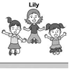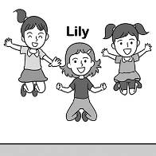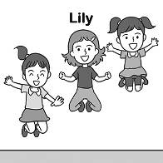

- (A) (B) (C)
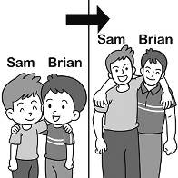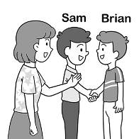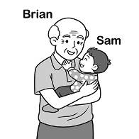

- (A) (B) (C)
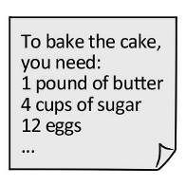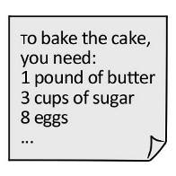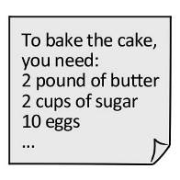

- (A) (B) (C)


- (A) (B) (C)
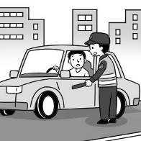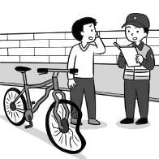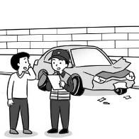

- (A) (B) (C)
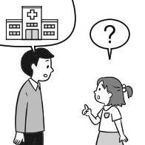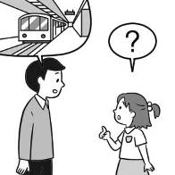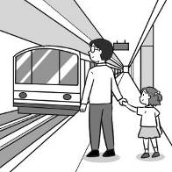

二、基本問答：每題均有三個選項，請依據所聽到的內容，
選出一個最適合的回應(7%)
- (A) It will be sent to her later.
(B) Yes, Julie asked you to call her.
(C) Yes, I have already finished it.

- (A) No, he wasn’t invited to the party.
(B) Yes. He studied the hardest of all.
(C) Yes. He ran the fastest of all.

- (A) He was sick, so he didn’t come.
(B) He won’t because he isn’t invited.
(C) He came although he wasn’t invited.

10.(A) How do you like this one?
(B) You’re such a nice person.
(C) Never mind. Don’t worry about it.

11.(A) I wonder where you found it.
(B) He’s a boy who doesn’t give up easily.
(C) He was lazy, so he didn’t even give it a try.

12.(A) No, I didn’t see it.
(B) No, you can sit here.
(C) Yes, I’ve never seen it.

13.(A) Until you join the baking club.
(B) Because it helps you sleep better.
(C) After you finish your meal and before you sleep.

三、言談理解：每題均有三個選項，請依據所聽到的對話
與問題，選出一個最適當的答案(7%)
14.(A) It’s loved by foreigners.
(B) It’s known only by the locals.
(C) It’s in the center of town.

15.(A) On foot.
(B) By bus.
(C) By metro.

16.(A) A lighter one.
(B) The newest one.
(C) The least expensive one.

17.(A) A teacher and his student.
(B) A seller and a buyer.
(C) A boss and his secretary.

18.(A) The woman is talking on the phone.
(B) The man and the woman are taking a rest.
(C) The man doesn’t respect other people the train.

19.(A) They will probably miss their train.
(B) He hopes the woman can help him pack.
(C) The woman can help him with the report.

20.(A) They’re going to go abroad.
(B) They just bought a new house.
(C) Their old apartment has been bought by
someone.

試題結束
請確認答案卡的座號

