**桃園市立大有國民中學112學年度第一學期第二次評量試卷**

|  |  |  |  |  |  |  |  |  |  |
| --- | --- | --- | --- | --- | --- | --- | --- | --- | --- |
| 年 級 | **八** | 考 試  科 目 | **英文** | | | 命 題  範 圍 | L3~Review II | 作 答  時 間 | 45分 |
| 班 級 |  | 姓 名 |  | 座 號 |  | 分 數 |  | | |

**一、辨識句意-根據聽到的內容，選出正確的圖片代碼**：

1. (A)　　　　　(B)　　　　　(C)　　　　　  
   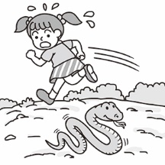 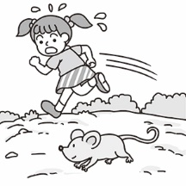 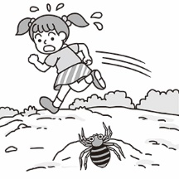
2. (A)　　　　　(B)　　　　　(C)　　　　　  
   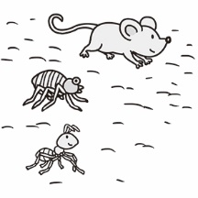 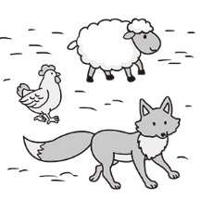 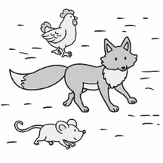
3. (A)　　　　　(B)　　　　　(C)  
   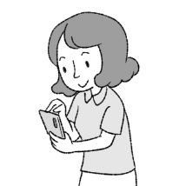 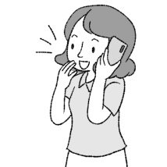 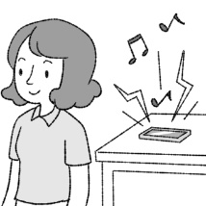
4. (A)　　　　　(B)　　　　　(C)  
   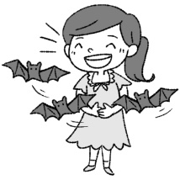 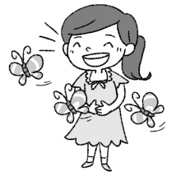 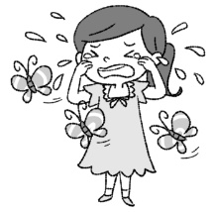
5. (A)　　　　　(B)　　　　　(C)  
   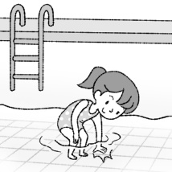 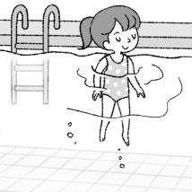 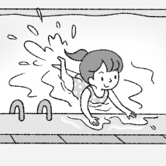

**二、基本問答-根據聽到的內容，選出合適的回應**：

1. (A) Wow. Let’s play a game.  
   (B) Cool. He must be so happy!  
   (C) OK. He needs to practice more.
2. (A) I have a lot of classes every week.  
   (B) English classes here are expensive.  
   (C) About $1,000 an hour.
3. (A) Doing housework is boring.  
   (B) I spent more than two hours cleaning the kitchen.  
   (C) After I enjoyed the food.
4. (A) Well, I finally found a work.  
   (B) I started it just after 10 o’clock.  
   (C) Yes. I have two math classes today.
5. (A) I didn’t like hiking before.  
   (B) Lily, please give me a break.  
   (C) There is no fresh air on Earth.

**三、言談理解-根據聽到的對話內容與問題，選出正確的答案**：

1. (A) The boy is planning a trip right now.  
   (B) The girl is preparing for her trip now.  
   (C) The girl is camping in the mountains now.
2. (A) The man cried at the end of the movie.  
   (B) The woman watched the movie last night.  
   (C) The woman had to prepare for the math test during the movie.
3. (A) He didn’t read it all.  
   (B) He didn’t like the ending.  
   (C) The woman asked for it back before he finished it.
4. (A) John is jumping.  
   (B) John cried last Sports Day.  
   (C) John got first place last year.
5. (A) She went swimming in the river.  
   (B) She rode a bike along the country road.  
   (C) She sang and danced at the camping place.

**四、文法選擇**

1. Abby breakfast at 6:30 this morning.   
   (A)was making (B) was to make   
   (C) making (D) was made
2. Ben walked to school he had breakfast at home with his family.  
   (A)because (B) when (C) before (D) after
3. When Jennie home, Maria was doing the dishes.  
   (A)got (B) was getting (C) get (D) gets
4. Grandma goes to bed, she usually drinks a cup of hot milk.   
   (A)Between (B) During (C) After (D) Before
5. They were having dinner .   
   (A)ago (B) then (C) before (D) after
6. When the doorbell rang, Pete in the room.   
   (A)slept (B) sleeps (C) is sleeping (D) was sleeping
7. Paul mice on her grandpa’s farm last Monday evening.   
   (A)see (B) sees (C) was seeing (D) saw
8. They can’t go out the rain.   
   (A)because of (B) because (C) beside (D) and
9. Ivy spent half an hour her lunch.   
   (A)to eat (B) eats (C) eating (D) eats
10. Gary planned abroad last month.   
    (A)going (B) to go (C) go (D) went
11. The dog kept after these kids.   
    (A)to run (B) runs (C) running (D) ran
12. Did she enjoy with you last night?  
    (A)to dance (B) dance (C) dancing (D) studied
13. Let’s begin at ten this morning.   
    (A) to study (B) study (C) to studying (D) to go
14. The little girl loves chopsticks.   
    (A)practices using (B) practicing using   
    (C) to practice to use (D) practicing use
15. Megan: How can I be a supermodel(超模) like you?

Irene: You have to swim and jump rope every day.

And you can’t have any snacks after 7:00 p.m.

Megan: .   
(A) Give me a break!

(B) Long time no see.

(C) Wow! That’s special.

(D) What a good experience!

|  |
| --- |
| Just like people, animals may be sick and need to see a doctor. Of course, a doctor for animals is different from that for people. An animal doctor is called a veterinarian, or a vet. Some vets work in big cities, and they look after family pets. When do you take your pet to the vet? It has a bad cold or eat something bad, and it’s time to take it to the vet. Also, about every six months, you need to take your pet to the vet for shots or checks. Some vets work on farms to help sick farm animals, such as pigs, horses, and sheep. Sometimes they help a cow to give birth to a baby.  Some vets work at the zoo. They take care of zoo animals. How does a zoo vet help ferocious animals, like lions and tigers, or big animals like elephants? You can get online and search for the answers.  ￭ called 稱為 shot 注射 check 檢查 such as 像 give birth 出生 ferocious 兇猛的 search 搜尋 |

1. From the reading, how many times should you take your pet to the vet?   
   (A)Every year.  
   (B)Twice a year.   
   (C)Six times a year.  
   (D)Once a month.
2. What can we know from the reading?  
   (A)Animal doctors are the same as doctors for people.   
   (B)Zoo vet’s job is to help zoo animals give birth to their babies.   
   (C)We can get online to know a zoo vet’s way to help zoo animals.   
   (D)Farm vets help us with some ferocious animals like pigs or horses.

|  |
| --- |
| It is lots of fun to have a family vacation, but people usually spend lots of time getting to their vacation spots. There’s nothing like sitting in a car for a long time to make a person bored. Try playing one of these travel games next time if your family takes a long road trip.  Game 1: I Spy ― This game is really easy. You just say “ I spy with my little eyes, something red, orange, or yellow …” and anyone in the car looks around and guesses the thing. You can make the rules, like only outside the car or not guessing the same thing twice.  Game 2 : *Who Am I?* ― It’s an easy game. After you think of someone famous, everyone can ask you one yes-no question at a time and you can have something in mind. You can also guess animals or anything, like food or drinks.  Game 3: *Beep ―* Pick any brand of the car at the start of your trip. For example, if you choose “Honda,” each time you see the brand of car, say “beep” and get one point. The first person to get ten points wins the game.  Game 4 : *Word Chain ―* Anyone can start the game by saying any word. For example, if you say “pig” and the next one can say any word starting with the letter g, like “green.” The game can go on until one can’t spell any word.  ￭ vacation 假期 spot 景點 bored 感到無聊的 rule 規則 mind 心裡 brand 品牌 until 直到 |

1. What’s the best title(最好的標題) for the reading?  
   (A)Fun Travel Games   
   (B)How to Win the Game?  
   (C)How to Drive the Car?  
   (D)Long Road Trips
2. The Brown family played *World Chain* when they took a trip to Taipei. Mr. Brown said “keep” and Mrs. Brown said “practice.” Then it’s their son’s turn. What should he say to pass the game?  
   (A)Live (B) Begin (C) Experience (D) Prepare
3. Which is NOT true about the games?  
   (A)You can ask yes-no questions when you play Game 2.   
   (B)When you play Game 1, you need to know colors.   
   (C)You need to look for cars when you play Game 3.   
   (D)You don’t need to know any English words when you

play Game 4.

------------------------------------------------------------------------------------------------------------------------------------------------------------------------

* 非選題 **(請在答案卷作答)** 滿分30 分

**一、單字** **(一格1分, 限1字)**

1. 大笑 2. 可能的 3. 底部 4. 感到驚訝的 5. 困難的

6. 女服務生 7. 課程 8. 推銷員 9. 了解 10. 漁夫

11. 國王 12. 蜘蛛 13. 海灘 14. 堂表兄弟姊妹 15. 工廠

**二、填空(一題1分, 不限一字)**

16. Fred ________ (wake) up late last Monday morning.

17. Ben ____________ (cry) for help at that time.

18. Jennie ____________ (play) baseball at 5:00 p.m. yesterday.

19. Gina finished _________ (draw) the picture ten minutes ago.

20. Molly needed ________ (finish) the report (報告) in time.

21. Amy wants ________ ( listen) to some music.

**三、改寫 (一題3分)**

22. The worker spent one hour washing clothes yesterday. (依畫線部分造原問句)

23. The teacher spent one thousand dollars on the cake. (依畫線部分造原問句)

24. Joyce washes her hands before she has the meal. (用 … after… 改寫句子)