**桃園市立大有國民中學113學年度第一學期第三次評量試卷**

|  |  |  |  |  |  |  |  |  |  |
| --- | --- | --- | --- | --- | --- | --- | --- | --- | --- |
| 年 級 | **八** | 考 試  科 目 | **英語** | | | 命 題  範 圍 | L5 ~ L6, Review3 | 作 答  時 間 | 45分 |
| 班 級 |  | 姓 名 |  | 座 號 |  | 分 數 |  | | |

**A: 聽力測驗 每題2分**

**一、辨識句意：每題均有三張圖片，請依據所聽到的句子，選出符合描述的圖片。**

1. (A)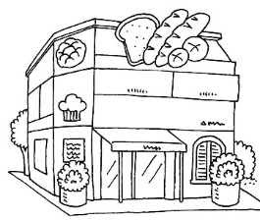 (B)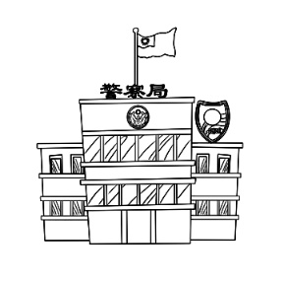 (C)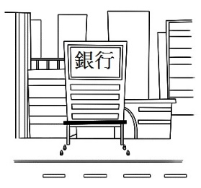
2. (A)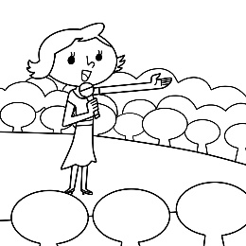 (B)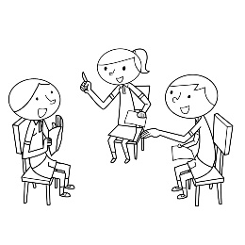 (C)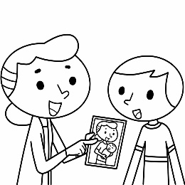
3. (A)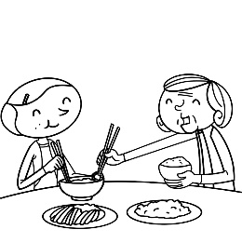 (B)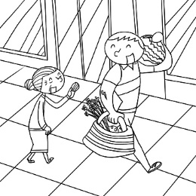 (C)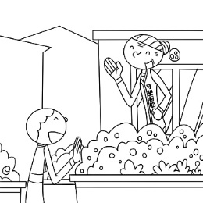
4. (A)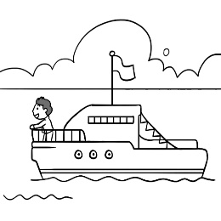 (B)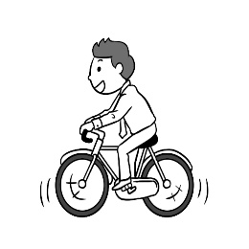 (C)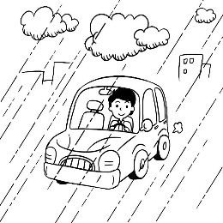
5. (A)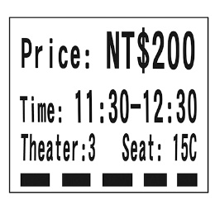 (B)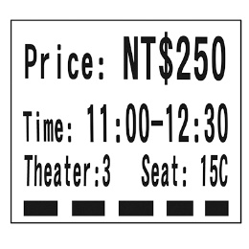 (C)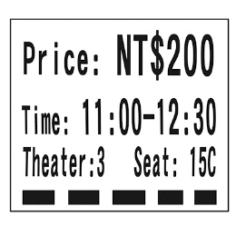

**二、基本問答：每題均有三個選項，請依據所聽到的內容，選出一個最適合的回應。**

1. (A) I will live with my uncle in the country.  
   (B) I will find a flower shop there.  
   (C) We will stay in the hotel by the river.
2. (A) Yes, but I don’t go shopping there very often.  
   (B) Yes, and I often hike in the mountains.  
   (C) Yes, because I will visit the sights in the city.
3. (A) You have to turn right and walk for one block.  
   (B) You shouldn’t make any noise there.  
   (C) You live near the train station.
4. (A) Because it is dead.  
   (B) Because I use it to do many things.  
   (C) Because my parents bought me a new one.
5. (A) I’m sorry, young lady. I can’t stop or park the car on the red line here.  
   (B) We are lucky. There are two clerks in the tea shop.  
   (C) You made a big mistake. You took the wrong bus.

**三、言談理解：每題均有三個選項，請依據所聽到的對話與問題，選出一個最適當的答案。**

1. (A) At a bank. (B) At a post office. (C) At a flower shop.
2. (A) The man won’t team up with her. (B) She is afraid of getting hurt. (C) Watching it is more fun.
3. (A) Give the old lady money. (B) Buy the old lady a drink. (C) Bring the old lady a coat.
4. (A) A supermarket. (B) A fruit store. (C) A flower shop.
5. (A) They are going to find a nice hotel on Google.

(B) They are going to look around the city by boat.  
(C) They will visit some museums tomorrow.

**B 綜合測驗 (16 --- 50每題2分)**

1. 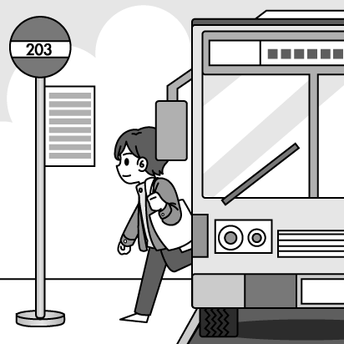Look at the Picture 1. How does the boy go to school every day?
2. He goes to school by bus.
3. He goes to school by scooter.
4. He goes to school by metro. Picture 1
5. He goes to school by train.
6. Ian: There is a new ________ next to Taoyuan train station. Do you want to visit it?

Ivy: Sure. I will shop for a gift for my sister.

1. post office (B) church (C) elementary school (D) department store
2. My grandparents are ________ lovers, so they go hiking in the mountains every weekend.
3. bookstore (B) nature (C) bakery (D) supermarket
4. The metro staion is just across from my home. It is ________ for me to go to school by MRT every day.
5. expensive (B) straight (C) convenient (D) wrong
6. Kaohsiung (高雄) is in the ________ of Taiwan. It is usually sunny there.
7. east (B) north (C) west (D) south
8. Chinese New Year is coming. Tom and his family will take a trip to Japan, and my family ________, too.
9. won’t (B) are (C) will (D) aren’t
10. Katie didn’t come to school today, but she said, “I ________ there the day after tomorrow.”
11. will go to (B) was going to (C) will (D) am going to be
12. Playing basketball isn’t difficult for Lily because she spends a lot of time ________ it with her friends every day.
13. practicing (B) practice (C) practiced (D) to practice
14. Fred was late to school this morning because of the heavy traffic. It ________ him two hours ________ to school.
15. spent; to get (B) took; to get (C) spent; getting (D) took; getting
16. Alice: Your shoes look great. How much did you pay ________ them?

Helen: It ________ me NT$5000 to buy them.

1. for; spent (B) to; took (C) to; paid (D) for; cost
2. Dad: Remember to do your homework before playing the video games.

Son: Ok. I ________ it soon.

1. do (B) will do (C) am doing (D) did
2. ________ a welcome party next Friday night for our cousin. Would you like to join us?
3. There is going to have (B) There will have (C) There is going to be (D) There was
4. Tony: ________ does the sofa cost?

Gary: It ________ twenty thousand NT dollars.

1. How far; pays (B) How long; take (C) How much; costs (D) How many; cost
2. Cindy: ________ Jack go to Taipei 101 yesterday?

Tony: He ________ the metro there .

1. How does; drove (B) How do; rode (C) How did; took (D) How can; flew
2. Jack: ________ they going to ________ a trip to Japan next month?

Jane: I don’t know.

1. Are; take (B) Will; take (C) Is; take (D) Are; took
2. Which one is correct?
3. The dog is sleeping in the corner of the room. (B) The dog is sleeping on the corner of the room.

(C) The dog is sleeping between the tree. (D) The dog is sleeping in there..

1. Grandson: I really like the new Iphone, but it is too ________. I don’t have enough money.

Grandma: Don’t worry about it. I can buy it ________ you.

1. expensive; to (B) cheap: for (C) expensive; for (D) cheap; to
2. Man:Excuse me. Is there a post office near here?

Woman: Yes. Walk ________ Dayou Road ________ two blocks, and you can see it on your right.

1. straight; to (B) down; on (C) along; for (D) cross; past
2. During the winter, ________ birds usually fly to Taiwan from Japan because it is very cold there.
3. eight hundreds of (B) three dozens (C) two thousands (D) thousands of
4. Lisa: Why do you look so happy?

Jane: It is because my boyfriend and I________ for Singapore to join his sister’s wedding tomorrow morning.

1. are leaving (B) am leave (C) will leaving (D) are going to

**閱讀測驗一**

|  |
| --- |
| Chinese New Year of 2025 is coming soon. Chinese people would like to buy some new clothes to celebrate this festival. Sunshine Department Store is going to have a big sale online during January 10 -- 25. Tomorrow is the first day of the sale. There will be a 70% off on all items. The shipping fee will be free if your order is over NT$2000. Megan got the message from the department store this morning. She wants to buy some clothes, so she decided to do online shopping tomorrow.  MUr47  shipping fee 運輸費 item 品項 off 折扣 message 訊息 order 訂單 |

1. When will Megan do online shopping at Sunshine Department Store?
2. Today (B) January 10 (C) January 15 (D) January 25

1. Megan is going to buy a dress, a skirt(裙子), a shirt, and a pair of jeans(牛仔褲). How much will she spend on them?
2. $2250 (B) $6500 (C) $5500 (D) $4300
3. Megan can save some money from her shopping. How much money can she save from her order?

(A)She can save $2250. (B) She can save $6000. (C) She can save $4500. (D) She can save $5250.

1. Which is true?
2. Shoes are on sale, too.
3. Magan can buy cheap clothes before January 10.
4. Megan doesn’t need to pay the shipping fee.
5. The big sale will last eleven days.

**閱讀測驗二**

|  |
| --- |
| What are you going to be in the future? How are you going to make a successful career plan? The following ways might be able to help you.  1. You are 100% responsible for your life. No one can decide for you. You must take full responsibilty for your career planning.  2. Give yourself time to think. Ask yourself: “What do I really want?” “What do I care about most?” “What do I want my life to look like in the future?” Think carefully. You might want to make your career decision based on your answers above.  3. Set your goals. Dream big but start small. To reach your final big goal, you need to break it down into short, medium, and long term goals. And take a small step each time.  4. Know your abilities. Know your strengths and weakness. Use your strengths and minimize your weaknesses.  5. Find a career **mentor**. Find one or some mentors. They can give you useful advice.  6. Try new things. Learning can bring you new ideas and find your true interests.  🕮 career 職業 be able to 能夠 responsible有責任的 responsibilty責任 yourself你自己 carefully仔細地 based on根據 goal目標 medium中程的 long term長程的 ability能力 strength優點 weaknes缺點 minimize減少 advice建議 |

1. What is the best title (最佳標題) for this reading?

(A)Ways to Know Your Ability (B) Plan Your Career

(C) New Things to Learn (D) What People Care About

1. How many ways does the writer offer (提供) to help you make a sucessful career plan?

(A)Six (B) Four (C) Two (D) One

1. What does the word **mentor** mean?

(A) clerk (B) monster (C) teacher (D) baker

1. Which is true?
2. Learning new things is not important.
3. Your parents are 100% responsible for your future.
4. No one can make a decision for your future.
5. Finding your interests isn’t good for your career plan.

**克漏字測驗**

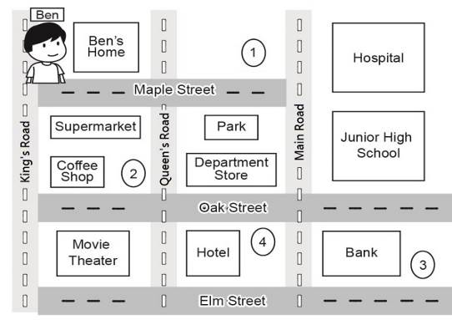

(Outside Ben’s house)  
Ben：You really made this week’s math lesson easy to understand, thanks.  
Julie：Glad I could help. Can you tell me how do I get to the museum from here? I am going to meet a friend

there later.  
Ben：Sure, it’s just around here. Walk (**44.** ) Maple Street to Main Road. It’s (**45.** ) your left and right

at the corner. You can’t miss it.  
Julie：Cool. By the way, when I came out of the metro station, I saw a coffee shop. Is it good?  
Ben：I’m not sure, but there is a restaurant on Oak Street. There is a lot of delicious food, and I enjoy the hamburgers

there.  
Julie：Oh, that sounds good. Where is the restaurant?  
Ben：It’s **(46.** ) a hotel.  
Julie：How do I get there from here?  
Ben：You can go along King’s Road, turn left at the coffee shop, and keep (**47.** ) to Main Road. It’s

(**48.** ) Oak Street and Main Road.  
Julie：Great! Thanks for all the information. So, same time same place next week?  
Ben：Yes, please! Bye.

🕮 understand 了解 glad 高興的 sound 聽起來 information 資訊

1. (A) down　 (B) straight　 (C) past　 (D) across
2. (A) of　 (B) in　 (C) at　 (D) on
3. (A) next to 　 (B) in 　 (C) between　 (D) on
4. (A) to walk　 (B) walking　 (C) walked　 (D) walk
5. (A) next to　 (B) at the corner　 (C) on the corner of　 (D) between
6. Which one is the museum ?
7. (B) (C) (D)
8. Which one is the restaurant?

(A) (B) (C) (D)

**~~ END ~~**

**MAY YOU ALL HAVE A WONDERFUL CHINESE NEW YEAR!**

**桃園市立大有國民中學113學年度第一學期第上次答案卷**

|  |  |  |  |  |  |  |  |  |  |
| --- | --- | --- | --- | --- | --- | --- | --- | --- | --- |
| 年 級 | **八** | 考 試  科 目 | **英語** | | | 命 題  範 圍 | L 5 ~ L 6,Review 2 | 作 答  時 間 | 45分 |
| 班 級 |  | 姓 名 |  | 座 號 |  | 分 數 |  | | |

**每題2分，共100分。**

|  |  |  |  |  |
| --- | --- | --- | --- | --- |
| **1. A** | **2.A** | **3.B** | **4.B** | **5.C** |
| **6.C** | **7.B** | **8.A** | **9.B** | **10.A** |
| **11.C** | **12.B** | **13.B** | **14.A** | **15.C** |
| **16.A** | **17.D** | **18.B** | **19.C** | **20.D** |
| **21.C** | **22.D** | **23.A** | **24.B** | **25.D** |
| **26.B** | **27.C** | **28.C** | **29.C** | **30.A** |
| **31.A** | **32.C** | **33.C** | **34.D** | **35.A** |
| **36.B** | **37.A** | **38.D** | **39.C** | **40.B** |
| **41.A** | **42.C** | **43.C** | **44.A** | **45.D** |
| **46.A** | **47.B** | **48.C** | **49.A** | **50.D** |