**桃園市立大有國民中學112學年度第一學期第一次評量試卷**

|  |  |  |  |  |  |  |  |  |  |
| --- | --- | --- | --- | --- | --- | --- | --- | --- | --- |
| 年 級 | **八** | 考 試  科 目 | **英語科** | | | 命 題  範 圍 | L1~Review 1 | 作 答  時 間 | 45分 |
| 班 級 |  | 姓 名 |  | 座 號 |  | 分 數 |  | | |

**一、辨識句意-根據聽到的內容，選出正確的圖片代碼，每題2分，共10分**

1. (A)　　　　　 (B)　　　　 (C)　　　　　  
   一張含有 寫生, 線條藝術, 圖解, 美工圖案 的圖片

   自動產生的描述 一張含有 寫生, 線條藝術, 美工圖案, 圖解 的圖片

   自動產生的描述 一張含有 寫生, 圖畫, 線條藝術, 足部穿著 的圖片

   自動產生的描述

2. (A)　　　　 　(B)　　　　 　(C)　　　　　

3. (A)　　　　　 (B)　　　　 　(C)　　　　　

4. (A)　　　　　 (B)　　　　　 (C)　

5. (A)　　　　 　(B)　　　　　 (C)　　　　　

**二、基本問答-根據聽到的內容，選出合適的回應，每題2分，共10分**

6. (A) I watched it a few days ago. (B) I was curious about the ending. (C) It reminded me of my grandfather.

7. (A) I ate something an hour ago. (B) I was late and didn’t eat breakfast. (C) I just bought some bread for lunch.

8. (A) She broke her arm. (B) That happens a lot. (C) I saw Mary last evening.

9. (A) I was also poor then. (B) Sure. What can we do? (C) Why don’t you like her?

10. (A) Yes, I went to America last summer. (B) I visited my relatives in Japan. (C) I usually go to the beach every summer.

**三、言談理解-根據聽到的對話內容與問題，選出正確的答案，每題2分，共10分**

11. (A) They cleaned the desk. (B) They walked on the street. (C) They celebrated the New Year.

12. (A) Made a pie. (B) Fed the animals. (C) Played computer games.

13. (A) The man made it. (B) The woman’s aunt gave it to her. (C) The woman took it from the USA.

14. (A) Shoes. (B) Candy. (C) Computers.

15. (A) Two rabbits. (B) A dog, a cat and a rabbit. (C) A cat and a rabbit.

**四、單字及文法， 第1-25題，每題2分，共50分**

1. Look at the picture. The birthday girl is blowing the _____.

|  |  |  |  |
| --- | --- | --- | --- |
| 1. hats | 1. candles | 1. candy | 1. cake |

1. Hey, the _____ is smiling. He is so cute.

|  |  |  |  |
| --- | --- | --- | --- |
| 1. story | 1. circle | 1. fear | 1. baby |

1. At the _____ of 42, Tom finally had his own house.

|  |  |  |  |
| --- | --- | --- | --- |
| 1. age | 1. end | 1. stand | 1. meal |

1. We _____ trees and vegetables in our new garden.

|  |  |  |  |
| --- | --- | --- | --- |
| 1. played | 1. placed | 1. planted | 1. planned |

1. Her family was _____ and didn’t have a computer.

|  |  |  |  |
| --- | --- | --- | --- |
| 1. poor | 1. last | 1. sweet | 1. lively |

1. The old man can’t _____ his way home. Let’s check his name card on his neck.

|  |  |  |  |
| --- | --- | --- | --- |
| 1. remind | 1. watch | 1. remember | 1. cry |

1. Yesterday my family _____ peaches and enjoyed the nice view.

|  |  |  |  |
| --- | --- | --- | --- |
| 1. pick | 1. picked | 1. break | 1. broke |

1. I don’t know what to do and I’m _____ of telling her the truth.

|  |  |  |  |
| --- | --- | --- | --- |
| 1. well | 1. scared | 1. happy | 1. sad |

1. We _____ Aunt JoJo’s pet dog when she is away.

|  |  |  |  |
| --- | --- | --- | --- |
| 1. remind of | 1. pass away | 1. take action | 1. look after |

1. Grandma was a math teacher _____, and my father _____, too.

|  |  |  |  |
| --- | --- | --- | --- |
| 1. after/ weren’t | 1. then/ wasn’t | 1. ago/ was | 1. before/ was |

1. The magic show starts at 1 o’clock, _____let’s meet at the Apple Square at twelve forty-five.

|  |  |  |  |
| --- | --- | --- | --- |
| 1. so | 1. or | 1. because | 1. but |

1. We can’t go to Julia’s party _____ we’re going away that weekend.

|  |  |  |  |
| --- | --- | --- | --- |
| 1. but | 1. and | 1. because | 1. so |

1. A: Why _____ Allen late for school again? B: He _____ the train.

|  |  |
| --- | --- |
| 1. did / didn’t catch | 1. wasn’t/ caught |
| 1. didn’t/ caught | 1. was/ didn’t catch |

1. A: How did you feel about this show? B: _____

|  |  |
| --- | --- |
| 1. I feel sorry for that. | 1. That was so sweet. |
| 1. It was so much fun | 1. It’s all about love, not fear. |

1. A: Did Eddie choose to stay in Japan? B: No. _____

|  |  |
| --- | --- |
| 1. Guess what? He was with me last night. | 1. He had no choice. |
| 1. Let’s take action now! | 1. What’s special about it? |

**五、克漏字及閱讀測驗**

**A.**

John：Why 31. you go to the movies alone last night? 32. to you and Mary?  
Bill：She didn’t go with me 33 .  
John：I see. So, she went to their place and took care of them?  
Bill：Not really. She was with them in the hospital.  
John： 34.  
Bill：They need to work today, so they didn’t stay there last night.  
John：Did Mary stay with her grandparents all night?  
Bill：Of course not. I went to the hospital after I watched the movie. I also bought a basket of apples for them.  
John：That’s very nice of you. Did you sit by their side with Mary all night?  
Bill：You bet.  
John：Wow, Mary’s family 35. love you very much now.

|  |  |  |  |
| --- | --- | --- | --- |
| 1. (A) do | (B)don’t | (C) did | (D) didn’t |
| 1. (A) What happened | (B)Guess what | (C) What’s the special | (D) Was that nice |
| 1. (A), so she had lots of work to do. | | (B) because both her grandparents caught a bad cold. | |
| (C) because our pet dog ran out. | | (D) and she had dinner with her friends. | |
| 1. (A) Why were Mary’s parents at home? | | (B) How did Mary’s parents go to the hospital? | |
| (C) Where were Mary’s parents? | | (D) What did Mary’s parents do? | |
| 35. (A) must | (B) should | (C) do | (D) can |

**B.**

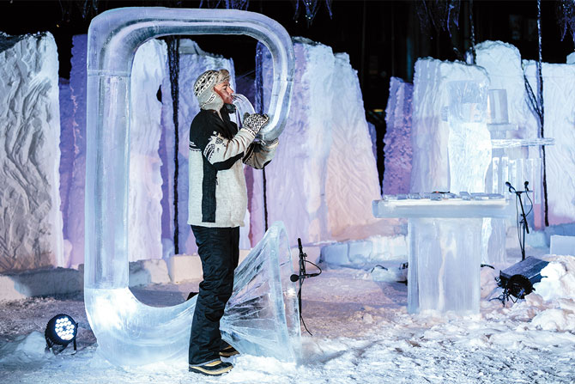Isungset is a musician from Norway. He got the idea for ice music over 20 years ago when he did a concert under a frozen waterfall. He wondered if he could make instruments out of ice and create ice music. “There were no people to ask how to do this. There were no books to read about it, and there was nothing on the Internet,” he said. “So I had to create everything by myself.” He uses ice from local lakes to make musical instruments. Isungset said, “It’s nature that decides the sound of the instrument.”

In 2006, Isungset helped start the first Ice Music Festival Norway in Europe. Every year, musicians play inside a unique space built out of ice and snow. Almost everything at the Ice Music Festival is frozen. When the show is over, Isungset invites the audience to give the ice instruments back to nature.

Isungset is a drummer, but he makes many instruments. Some of his instruments are based on standard ones, and some are his inventions. For the festival, he tries to invent a new instrument every year. His ice instruments are pretty cool, aren’t they?

nature(n.)大自然decide(v.)決定unique(adj)獨特的drummer(n.)鼓手standard(adj.)標準的invention(n.)發明frozen(adj.) 結冰的instrument(n.)樂器

1. From the reading, Isungset didn’t know how to make music from ice because ______

|  |
| --- |
| 1. people there didn’t like him. |
| 1. there were no books to read about it. |
| 1. the ice from the lake wasn’t cheap. |
| 1. his friends didn’t want to tell him. |

1. What does “give the ice instruments back to nature” mean?

|  |
| --- |
| 1. Throwing ice instruments into the lake. |
| 1. Giving the ice instruments to friends. |
| 1. Taking the ice instruments home. |
| 1. Drinking the water from the lake. |

1. According to the reading, which is TRUE?

|  |
| --- |
| 1. Isungset can make new music instruments. |
| 1. Only musicians can join the music festival. |
| 1. The Ice Music Festival was only in 2006. |
| 1. Musicians at the Ice Music Festival play music next to the lake. |

***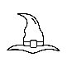*C.**

***I like to wear my pointed hat***

***I have a friend, a green cat***

***A broom is for flying in the air, not for cleaning***

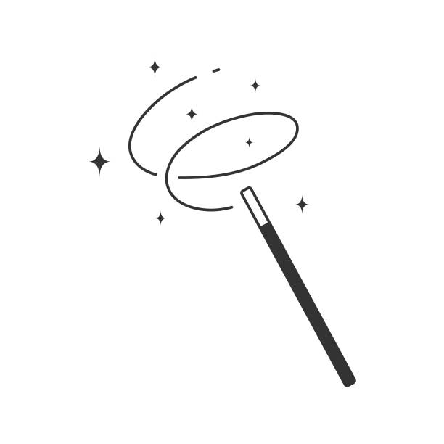***Don’t make me angry, or troubles are coming***

***Just say some words, and wave my magic wand***

***A magic show begins.***

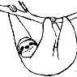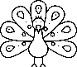***Don’t mess with me. Keep this in mind.***

***If I am unhappy, I’ll turn you into a peacock, a toad, or worse, a sloth.***

***You won’t be a man anymore.***

1. 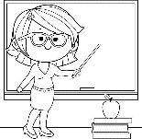Who is “I”?
2. (B)  (C)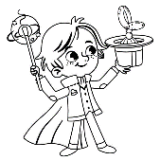 (D) 
3. After I said some words and _____, Charlie turned into a frog. Please don’t make me angry again.
4. swept the floor
5. flew into the sky
6. the show began
7. waved the magic wand

**桃園市立大有國民中學112學年度第一學期第一次評量試卷**

|  |  |  |  |  |  |  |  |  |  |
| --- | --- | --- | --- | --- | --- | --- | --- | --- | --- |
| 年 級 | **八** | 考 試  科 目 | **英語科** | | | 命 題  範 圍 | L1~Review 1 | 作 答  時 間 | 45分 |
| 班 級 |  | 姓 名 |  | 座 號 |  | 分 數 |  | | |

**六、文意字彙，請依句意填入適當單字，每字1分，共5分**

1. _______________ The weather in Taiwan is too hot. Many people can’t s d it.
2. _______________ Ms. Wang asked us to sit in a c e, join hands and danced to the music.
3. _______________ Mom is poor at cooking, and she is a t e cook.
4. _______________ We should always wash hands before m ls.
5. _______________ The meeting started at nine and f hed at three.

**七、動詞變化，每字1分，共7分**

46. Tom _______________(have) a headache, and _______________(become) sick yesterday.

47. Because Julie didn’t _____________(like) chocolate, she _____________(give) it to her sister.

48. A: Where ________(be) you this morning?

B: I _____________(go) to the supermarket and ______________(buy) some milk and eggs.

**八、合併句子及翻譯，共8分**

49. Tom was busy / he didn’t have dinner

a. 以…so…合併句子(2分)

____________________________________________________________________________

b. 以…because…合併句子(2分)

____________________________________________________________________________

50. A: _______________________________________________________(根據底線造原問句4分)

B: Eason sold his computer because he needed some money.