**桃園市立大有國民中學113學年度第一學期第二次評量試卷**

|  |  |  |  |  |  |  |  |  |  |
| --- | --- | --- | --- | --- | --- | --- | --- | --- | --- |
| 年 級 | 七年級 | 考 試  科 目 | 英語 | | | 命 題  範 圍 | Unit3, Unit 4, Review 2 | 作 答  時 間 | 45分 |
| 班 級 |  | 姓 名 |  | 座 號 |  | 分 數 |  | | |

一、辨識句意：根據聽到的內容，選出符合描述的圖片或符合圖片的描述。 (每題1分)

1. ( )

(A) (B) (C)

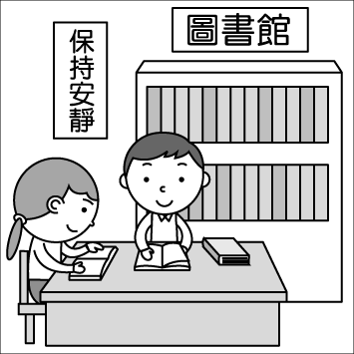 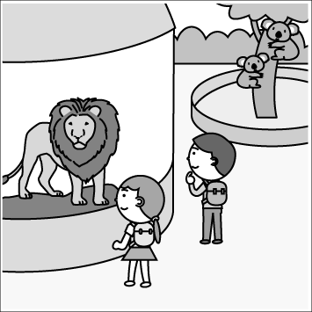 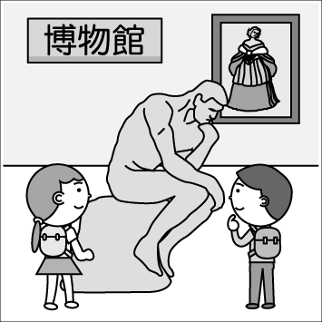

1. ( )

(A) (B) (C)

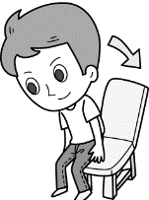 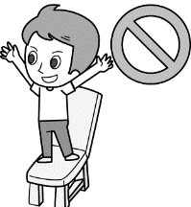 

1. ( )

(A) (B) (C)

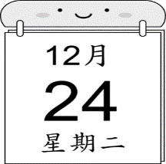 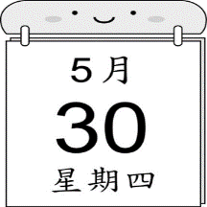 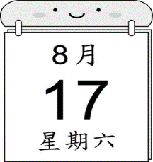

1. ( )

(A) (B) (C)

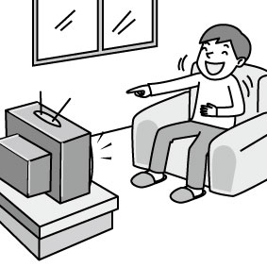 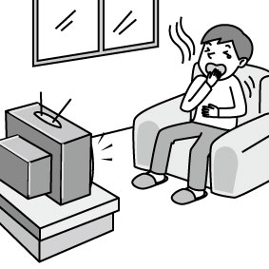 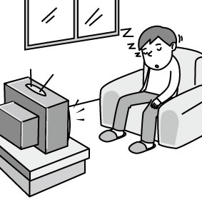

1. ( )

(A) (B) (C)

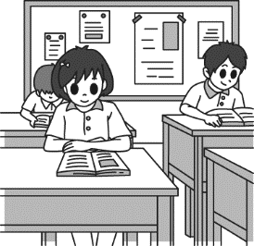 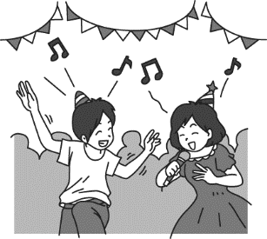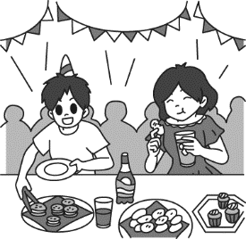

二、基本問答：根據聽到的內容，選出一個最適合的回應或最適合的問句。(每題1分)

1. ( )

(A)　Yes, we have a TV.  
(B)　Don’t turn off the TV.  
(C)　No. It’s time for bed.

1. ( )

(A)No, he can’t.

(B)　Sure. I can do that.  
(C)　Yes, you can open the door.

1. ( )

(A) You can go to the lab.  
(B) Go to the lab after class.  
(C) We can follow the lab rules.

1. ( )

(A) It is at ten.  
(B) It is 8 a.m.  
(C) The ball game is great.

1. ( )

(A) My brother is.  
(B) Let’s sing a song now.  
(C) They are dancing at the park.

三、言談理解：根據聽到的內容，選出一個最適合的答案。(每題2分)

1. ( )

(A) They are fighting.

(B) They are talking.  
(C) They are singing.

1. ( )

(A) Play.  
(B) Eat.  
(C) Draw comics.

1. ( )

(A) She is listening to music.  
(B) She is talking to JJ Lin.  
(C) She is dancing with the boy.

1. ( )

(A)　At six a.m. on Monday.  
(B)　At seven p.m. on Friday.  
(C)　At two p.m. every day.

1. ( )

(A) He is watching TV.  
(B) He is listening to music.  
(C) He is reading his comic book.

四、單一選擇題 (每題2分)

1. ( ) Mr. Wilson: Peter, wash your . You can

have lunch (午餐) in five minutes (五分鐘後).

Peter: I see, Mr. Wilson.   
 (A)　hands　 (B)　museums

(C) movies　 (D) signs

1. ( ) Mr. and Mrs. Stewart like to with their dog, Chili, at the park every weekend.

(A)　take a walk　 (B)　play basketball

(C)　turn on the TV (D)　wake up

1. ( ) Neil: Dad, can I go to the park after school?

Dad: Yes, you can. Be , please.　  
 (A)　hungry　 (B)　safe

(C)　dangerous　 (D) cute

1. ( ) Kelly: Are you next Friday? Let’s go to Bruno Mars’ concert.

Harry: Great. We can sing his songs together.　  
 (A)　quiet　 (B)　free

(C)　short　 (D) thin

1. ( ) Mitch: I listen to the song, *Last Christmas* many , but I still (依然) can’t sing it.

(A)　signs　 (B)　times

(C)　reports　 (D)　doors

1. ( ) Taipei City is a beautiful . Many visitors (遊客) come to this city every year.

(A)　rock　 (B)　house

(C)　place　 (D)　band

1. ( ) Brad is nervous(緊張的). He is standing on the

now. Everyone is looking at him.　  
 (A)　stage　 (B)　student

(C) video　 (D)　day

1. ( ) This is a movie. Many people go to theaters (戲院) and post (張貼) some pictures on Facebook.

(A)　together (B)　careful

(C)　popular　 (D)　hurry

1. ( ) Corey: What day is the party?

Zach: It is .　  
 (A)　Sunday　 (B)　on Sunday

(C)　six o’clock　 (D)　on six o’clock

1. ( ) Brian and Manny are my cousins. I play

with 　　　.

(A)　you (B)　your

(C)　they　 (D)　them

1. ( ) Lillian: Can you swim?

Louisa: . But I can dance.　  
 (A)　Yes, I can.　 (B)　No, I can’t.

(C)　Can I swim?　 (D)　Can’t I swim?

1. ( ) Miss Raya is our teacher. She is nice to .

(A)　we　 (B)　us

(C)　you (D)　my

1. ( ) My two-year-old brother in the bedroom

now. Please be quiet. 　  
 (A)　sleep　 (B)　am sleep

(C)　sleeping (D)　is sleeping

1. ( ) The baseball game is seven p.m.

Sunday.　  
(A)　at; on　 (B)　on; at

(C) on; ╳　 (D) ╳; at

1. ( ) Grace: you doing?

Hazel: I am eating an orange.　  
 (A)　Is　 (B)　What is

(C) Are (D) What are

1. ( ) It is not safe at this place. Let’s home.

(A) do not 　 (B) not

(C) go　 (D) we go

1. ( )Ronald: What is Hermione doing now?

Harry: 　  
 (A)　Yes, she is running at the park.

(B)　No, she isn’t washing the dog.

(C)　She is listening to music.

(D)　She isn’t eating or talking.

1. ( ) Jonathan:

Natalie: I think we are in front of the museum.　  
 (A)　Can people see us?

(B)　Can you follow the rules?

(C)　Where are we now?

(D)　What is behind you?

1. ( ) Siobhan: What time is our math class?

Saoirse: 　　　　  
 (A)　It is ten fifty-seven now.

(B)　It is at nine in the morning.

(C)　It is Monday.

(D)　It is in the lab.

1. ( ) Gabriel: Is the guy a police officer?

Alvin: Let’s ask him for help (幫助).　  
 (A)　I am fine. (B)　Sure.

(C)　Oh my! Run! (D)　Wake up. Time for class.

五、克漏字  (每題2分)

(36-39)

|  |
| --- |
| (In the living room)  Adele: Tommy, (36) is it now?  Tommy: It’s (37) in the evening now. Anything special?  Adele: My favorite TV show is coming.  Tommy: What is it about?  Adele: It is about a tennis player, Andy Murray.  Tommy: Oh no. You can’t watch it today.  Adele: Why can’t I watch the show?  Tommy: I’m sorry. My watch isn’t (38) . Look at the clock on the wall. It is already nine p.m. You can only watch BBC news.  anything 任何事情  special 特別的  about 和...有關  tennis 網球  news 新聞；消息  Adele: (39) |

1. ( ) (A) where　 (B) who

(C) what time　 (D) what day

1. ( )(A) seven thirty (B) p.m. seven thirty

(C) at seven thirty (D) in seven thirty

1. ( ) (A) run　 (B) can’t run

(C) is running　 (D) running

1. ( ) (A) Let’s jump. (B) I can’t wait!

(C) Nice video. (D) That’s a bad news to me.

六、閱讀測驗與克漏字 (每題2分)

(40-42)

|  |
| --- |
| (42) !   * No pets. * No cigarettes. * Do not run or jump. * Do not feed the animals. * Do not play with the animals. * Let’s love the animals. together.   pet 寵物 cigarette 香菸  feed 餵食 animal 動物  give 給 |

1. ( ) What can you do at the zoo?

(A) Play with the animals.

(B) Run with your cousins.

(C) Give some food to the animals.

(D) Love the animals with your parents.

1. ( ) Who **CAN’T** come to the zoo?

(A) Bob, a forty-year-old office worker.

(B) Dash, Bob’s son, twelve years old.

(C) Helen, a thirty-three-year old taxi driver.

(D) Picky, a pet dog in Bob’s house.

1. ( ) What is the best title (最佳標題)of the reading?

(A) Please Follow the Rules in the Zoo.

(B) Don’t Eat on the Bus.

(C) Let’s Play a Game.

(D) Be Nice to Your Friends.

(43-45)

|  |
| --- |
| (43)  breakfast 早餐 shop 商店meal 一餐 enjoy 享受 |

1. ( ) What can (43) be?

(A) morning

(B) afternoon

(C) music

(D) weekend

1. ( ) What time can you go to this breakfast shop?

(A) At one fifteen p.m.

(B) At two twelve p.m.

(C) At ten a.m.

(D) At five a.m.

1. ( ) What day **CAN’T** you go to Mr. Fairland’s shop?

(A) On Wednesday.

(B) On Tuesday.

(C) On Sunday.

(D) On Monday.

七、依提示作答 (每題1分)

請依照提示，寫出正確的現在分詞 (V-ing)。

1. play
2. make
3. hit
4. cut

請依照提示，寫出正確的英文單字。

1. Today is Wednesday. Tomorrow is T y .
2. Mr. Green is watching Aespa’s music v o. Aespa is a K-pop band.
3. Cody Wei has a m c door. With the door, he can go to the Keret House in 3 seconds (秒).
4. Be c l . Don’t break the tubes. (別打破試管)

八、翻譯 (每題3分)

1. 請不要在我的房間裡跳舞。

dance in room.

1. 讓我們一起不要在教室裡吃或喝吧。

eat drink in the classroom.

1. Miss Jang正在和她的粉絲們拍照。

Miss Jang pictures with her .

1. Mayday的演唱會是在幾點幾分？

is Mayday’s ?