**桃園市立大有國民中學113學年度第一學期第一次評量試卷**

|  |  |  |  |  |  |  |  |  |  |
| --- | --- | --- | --- | --- | --- | --- | --- | --- | --- |
| 年 級 | **八** | 考 試  科 目 | **English** | | | 命 題  範 圍 | Lesson1-Review1 | 作 答  時 間 | 45分 |
| 班 級 |  | 姓 名 |  | 座 號 |  | 分 數 |  | | |

**第一大提到第三大題為聽力測驗，請仔細聆聽 !**

**一、辨識句意：請依所聽到的句子，選出符合描述圖片。(10%)**

1. (A)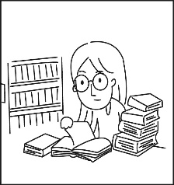 (B)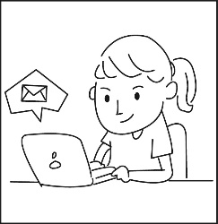 (C)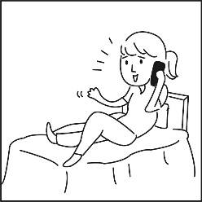

1. (A)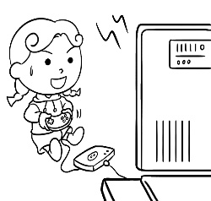 (B)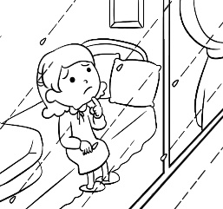 (C)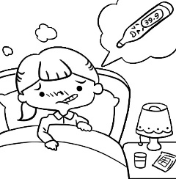

1. (A)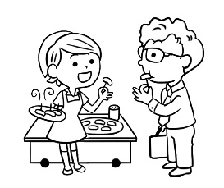 (B)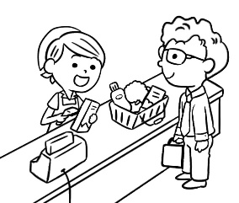 (C)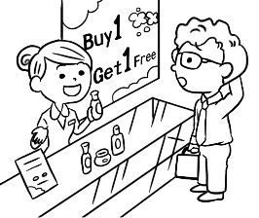

1. (A)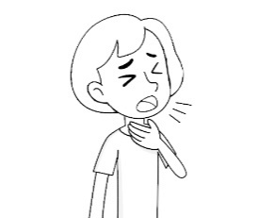 (B)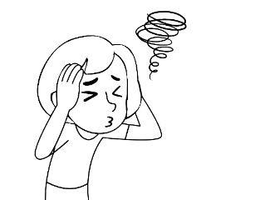 (C)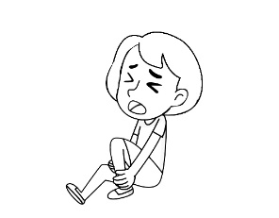

1. (A)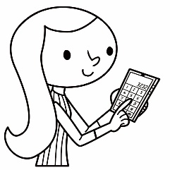 (B)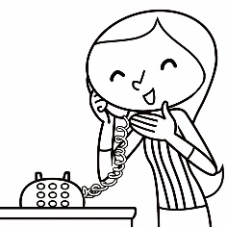 (C)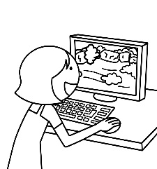

**二、基本問答：請依所聽到的內容，選出最適合的回應。(10%)**

1. (A) The view was wonderful there.  
    (B) We jogged and played basketball.  
    (C) I went to the park with my friends.
2. (A) I couldn’t ride a horse. It was hard.  
    (B) It was safe, and the view was wonderful.  
    (C) The ride lasted for ten minutes.
3. (A) Because I spoke to my teacher today.  
    (B) Because I didn’t catch a cold.  
    (C) Because I had a high fever.
4. (A) My parents waited for me at home.  
    (B) I learned a lot through this experience.  
    (C) My classmates and I went there together.
5. (A) No. I had a fever, so I stayed at home.  
    (B) Why so serious? This is just a movie.  
    (C) Sorry, I can’t go with you this weekend.

**三、言談理解：請依所聽到的對話與問題，選出最適當的答案。(10%)**

1. (A) Yes, it was interesting.  
    (B) No. It rained a lot then.  
    (C) No. She didn’t feel safe.
2. (A) She didn’t go to a temple.  
    (B) She didn’t enjoy the view at a beach.  
    (C) She didn’t prepare dinner for the man.
3. (A) He learned a lot about science.  
    (B) He learned about a basketball player’s life.  
    (C) He learned to play a sport.
4. (A) She surfed the Internet.  
    (B) She worked there before.  
    (C) She learned about that through an old man in the town.
5. (A) At a gift shop（商店）.  
    (B) At a temple.  
    (C) At a music festival.

**四、綜合測驗 (30%)**

1. I love reading _________ books in my free time. How about you?

(A) camp (B) comic (C) coat (D) clothes

1. Anna told us about her _________ in Japan.

(A) experience (B) festival (C) country (D) coat

1. Leo is a(n) _________ boy, so his classmates like him a lot.

(A) safe (B) healthy (C) serious (D) interesting

1. Mia and Amber _________ on a trip to Tainan last year. They _________ the nice food there.

(A) go; enjoy (B) went; enjoyed (C) go; enjoyed (D) went; enjoy

1. A: Where _________ you work last year?　B: I _________ in Taipei.

(A) do; work (B) are; am working (C) did; work (D) did; worked

1. A: _________ ? B: It was great. There was a lot of food.

(A) How was the party? (B) What did you do?

(C) Did you eat a lot? (D) What things caught your eye?

1. A: Why did you buy these clothes? B: I bought that clothes _________ they _________ beautiful.

(A) because; was (B) because; were (C) so; was (D) so; were

1. Elsa had a birthday party yesterday. Anna _________ a cake _________ her.

(A) gave; for (B) bought; from (C) made; for (D) ate; to

1. A: Why didn’t you come to the show? B: _________.

(A) I came to the show because it was interesting. (B) It was on Monday.

(C) I didn’t come to the show because I had a fever. (D) That’s too bad.

1. I have a sore throat, _________ I drank lots of water.

(A) so (B) but (C) or (D) because

1. A: What happened to your computer? B: _________.

(A) I bought it last weekend. (B) It fell on the ground and broke.

(C) I saw it on his desk. (D) I didn’t take it to the hospital.

1. A: Did you _________ Jim the book?　 B: Yes, I _________ him the book last night.

(A) gave; gave (B) gave; give (C) give; give (D) give; gave

1. A: Alan didn’t go to the science camp. _________ B: He had a headache.

(A) Who is your science teacher? (B) Why was he at home?

(C) What happened to you? (D) How was the camp?

1. A: What _________ your brothers do yesterday evening? B: They _________ yesterday evening.

(A) do; exercise (B) do; exercised (C) did; swim (D) did; swam

1. The bussinessman is very busy. _________, he always has dinner with his family.

(A) However (B) And (C) As for (D) Because

**五、 克漏字 (10%)**

Amy: Hi, Emma! How was your summer vacation?

Emma: It was wonderful! We ___ 31 ___ to Japan ___ 32 ___ a week. We visited Tokyo and Kyoto.

Amy: Wow! What did you do in Tokyo?

Emma: We visited a lot of famous places. On the first day, we visited Tokyo Tower, and then we went shopping.

Amy: That sounds fun! Did you try any Japanese food?

Emma: Yes! We ___ 33 ___ sushi almost every day. It was delicious.

Amy: ___ 34 ___

Emma: We ___ 35 ___ a train to Kyoto. Kyoto was beautiful. We visited temples.

Amy: Did you take any photos?

Emma: Of course! I had a great time there.

1. (A) go (B) visit (C) went (D) visited
2. (A) with (B) in (C) at (D) for
3. (A) ate (B) eats (C) eat (D) eated
4. (A) Who else did you meet? (B) Where else did you go?

(C) Did you eat anything else? (D) Why did you go to Kyoto.

1. (A) take (B) taked (C) took (D) takes

**六、閱讀測驗 (10%)**

Last Saturday, Peter went to the doctor because he didn’t feel well. He had a high fever, a bad headache, and he felt very tired. His mother was worried about him, so she took him to see a doctor. Peter told the doctor that he started feeling sick yesterday. He didn’t eat much because he had a sore throat. The doctor gave Peter some medicine and told him to rest for a few days. “You need to drink a lot of water and get enough sleep,” he said. Peter thanked the doctor and promised to follow his advice. Peter felt much better after taking the medicine and resting at home. By Monday, he was healthy again and ready to go back to school.

 invitation邀請函(n.) invite邀請(v.) excited興奮的(adj.) celebrate慶祝(v.) will 將會 happiness幸福(n.)

 promise承諾(v.) advice建議(n.) much better好多了 by 至…前

1. Why did Peter see a doctor last Saturday?

(A) He broke his arm.  
(B) He had a fever and a headache.  
(C) He wanted to visit a friend.  
(D) He had a toothache.

1. When did Peter start feeling sick?

(A) Last Monday.  
(B) On Saturday.  
(C) On Friday.  
(D) Ten days ago.

1. A: What did the doctor tell Peter to do to get better? B: The doctor told Peter to _________.  
   (A) take a walk every day  
   (B) go back to school  
   (C) drink water and rest for a few days  
   (D) eat more food and go outside

**Barbie and Kenny’s Wedding Invitation**

Dear Friends,

We are excited to invite you to celebrate our wedding! The wedding is on **Wednesday, October 16th, 2024**,

on the **sports field of DaYou Junior High School**. It will start at **6:30 p.m.**, and it will end at **9:00 p.m.**.

We chose this date because October is our favorite month. There is a karaoke machine at the wedding,

so everyone can sing your favorite songs! Please remember to wear something red to bring good luck

and happiness. We will have a ban-doh with around 10 dishes for dinner.

We can’t wait to see you there and celebrate this moment together!

Love,

Barbie and Kenny

1. Why did Barbie and Kenny choose to have their wedding in October?  
   (A) Because they like cool weather.  
   (B) Because October is their favorite month.  
   (C) Because the sports field is free in October.  
   (D) Because it’s a lucky month.
2. What can people do at the wedding?  
   (A) Watch a show.  
   (B) Sing songs.  
   (C) Play games.  
   (D) Dance.