桃 園 市 立 大 有 國 民 中 學 1 1 2 學 年 度 第 一 學 期 第 三 次 評 量 試 卷

|  |  |  |  |  |  |  |  |  |  |
| --- | --- | --- | --- | --- | --- | --- | --- | --- | --- |
| 年 級 | **七** | 考 試科 目 | **English** | | | 命 題範 圍 | Lesson5~Review3 | 作 答時 間 | 45 分 |
| 班 級 |  | 姓 名 |  | 座 號 |  | 分 數 |  | | |

**第一大提到第三大題為聽力測驗，請仔細聆聽 !**

# 一、辨識句意：請依所聽到的句子，選出符合描述圖片。

**(10%)**

1. **(A) (B) (C)**

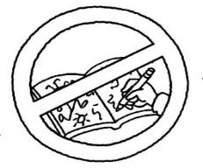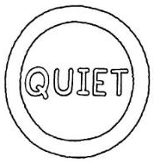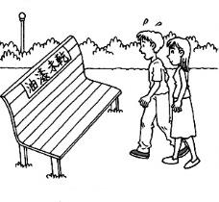

1. (A) That’s my wife.
   1. That’s my son.
   2. That’s my husband.
2. (A) It’s late.
   1. Let’s be careful.
   2. The room is quiet.

2. **(A)**

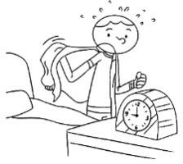

3. **(A)**

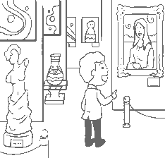

# (B)

**(B)**

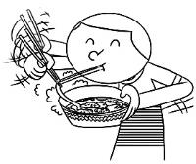

# (C)

**(C)**

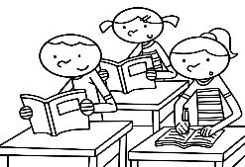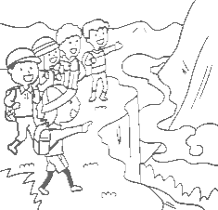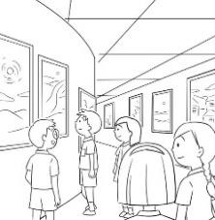

1. (A) Hurry up!
   1. Let’s talk about life.
   2. I’m making lunch for you.
2. (A) No, it’s Friday.
   1. No, it’s on Friday.
   2. No, it’s next Friday.

# 三、言談理解：請依所聽到的對話與問題，選出最適當的答案。(10%)

4. **(A) (B)**

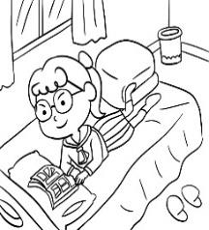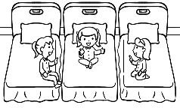

# (C)

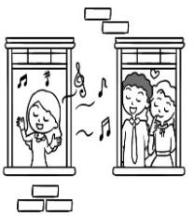

1. (A) In a metro station.
   1. On a sports field.
   2. In a library.

5. **(A)**

# (B)

**(C)**

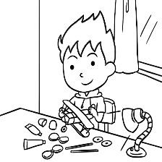

1. (A) She’s kind.
   1. She’s noisy.
   2. Her voice is beautiful.
2. (A) They are not hungry.
   1. Their favorite food is tea eggs.
   2. They are in the museum.

# 二、基本問答：請依所聽到的內容，選出最適合的回應。

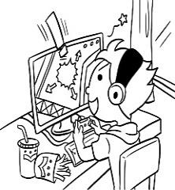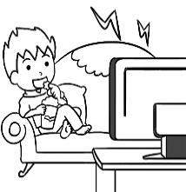

**(10%)**

6. (A) Here we are.

1. No problem.
2. She’s quiet.
3. (A) It’s on Friday night.
   1. It’s on Wednesday morning.
   2. It’s on Wednesday afternoon.
4. (A) It is tonight.
5. It is on Tuesday.
6. It is in the morning.

1

# 四、綜合測驗 (40%)

1. Watch out! Don’t the doors on the metro.
   1. listen to (B) lean on (C) look for (D) let’s
2. Mark: Where are you now?

Jackson: I am in New York. It’s my favorite .

* 1. station (B) city (C) museum (D) week

1. Hank, don’t shout at your sisters. Please be to .
   1. quiet; her (B) noisy; them (C) nice; them (D) kind; her
2. Leo: What are those girls eating?

Mia:

* 1. Yes. They are eating. (B) Don’t eat or drink.

(C) Some cakes. (D) They are in the living room.

1. Ms. Taylor: Jacob, don’t talk in class.

Jacob:

* 1. You’re welcome. (B) Watch out.

(C) It’s so noisy. (D) I am sorry.

1. Jessica: It’s 7:50 a.m. What time is the class?

Tiffany: It’s 8:30 a.m.

* 1. at; at (B) at; X (C) X; at (D) X; X

1. run in the classroom.
   1. Let’s not (B) Let’s don’t (C) Not (D) Let’s be
2. Henry: is it?

Kris: It’s 12 p.m. Time for lunch.

* 1. What day (B) What time (C) What (D) Where

1. Sandy:

Kitty: Yes, it is. It’s at 7 p.m.

* 1. What time is the meeting? (B) Don’t be late for the family dinner.

(C) Are you preparing for the tests? (D) Is the family dinner tonight?

1. , be nice to everyone, .
   1. Students; please (B) Please; students (C) Students; don’t (D) Please; not
2. Sophia: The cake is so nice.

Jared: Yes, but we are on the metro.

* 1. Here we are. (B) No problem.

(C) Let’s not eat here. (D) Where are you?

1. Owen: What is Stanley doing?

Casper:

* 1. Yes. He is running. (B) He is in the classroom.

(C) He is looking for his cellphone. (D) No, he is not doing his homework.

1. Lucas: What time is ?

Kevin: It’s 10 in the morning.

* 1. the group chat (B) the meeting (C) it (D) class

1. This movie is so cool. Let’s watch this weekend.
   1. it (B) its (C) they (D) them
2. Wendy: is Father’s Day?

Irene: It’s Wednesday. I am making a card for my dad.

* 1. What day; X (B) What time; at (C) What day; on (D) What time; X

1. Tony: Are your brothers dancing in the living room? Tim: They are eating in the dining room.
   1. Yes, he is. (B) No, he isn’t. (C) Yes, they are. (D) No, they aren’t.
2. Hey, let’s
   1. don’t shout in the museum. (B) closing the windows.

(C) not talking on the cellphone. (D) be quiet and listen carefully.

1. Emma and Sunny are sisters. mom loves very much.
   1. They; them (B) Their; they (C) They; their (D) Their; them
2. play in the metro station.
   1. Tony, please not (B) Please, Tony, don’t (C) Tony, please don’t (D) Please not Tony
3. Ivy a good girl. Jenny, a good girl, too.
   1. be; be (B) is; is (C) be; is (D) is; be

# 五、 克漏字、閱讀測驗(30%)



Owen: Hey, Marcus. 36.

Marcus: Hello, Owen. I 37. a surprise party.

Owen: A surprise party? That’s cool. Let’s 38. a cake for Jim. Marcus: Sure. But please don’t talk to 39. about the party.

Owen:Why not?

Marcus: It is a “surprise”.

Owen: Ok. 40. and have fun!

surprise 驚喜(n.) sure 當然(adv.) why 為什麼(adv.) plan 計畫(v.)

1. (A) Where are you?
2. What are you doing?
3. What day is the party?
4. How about you?
5. (A) am plan (B) plans (C) planning (D) am planning
6. (A) make (B) making (C) is making (D) please make
7. (A) he (B) his (C) he’s (D) him
8. (A) Be happy (B) Be noisy (C) Be late (D) Be sad



41. at the Museum

Welcome to Dayoyo Museum. Here are some 42. for our museum. Please follow them.

* No food or drinks.
* Please 43. quiet. Don’t make any noise.
* 44. the works of art.
* Don’t forget your things.

Have fun and have a nice day!

work of art 藝術品(n.) forget 忘記(v.)

|  |  |  |  |
| --- | --- | --- | --- |
| 41. (A) Eat or Drink | (B) Dos and Don’ts | (C) By the Way | (D) Quiet or Noisy |
| 42. (A) rules | (B) problems | (C) meetings | (D) days |
| 43. (A) X | (B) is | (C) be | (D) are |
| 44. (A) Look for | (B) Be careful of | (C) Wait in line | (D) Don’t shout |

# 45-47

Krystal’s Birthday Party

Date: 1/19 (Fri.)

Time: 6:30 p.m. ~ 8:30 p.m. Place: My new house

Please don’t bring any gifts.

Please don’t bring food or drinks. **They are on me**. Please bring your friends with you.

Please wear pink or white. Please come and join us.

Your friend,

Krystal

1. What is true about the party?



bring 帶來(v.) wear 穿(v.) join 加入(v.)

* 1. The party is at noon.
  2. The party is two hours long.
  3. It’s at Amber’s house.
  4. It’s on the weekend.

1. What can you do at the party?
   1. Go with friends.
   2. Wear blue clothes.
   3. Prepare gifts for Krystal.
   4. Come at 6 in the morning.
2. What is “**they are on me**”?
   1. Food and drinks are for Krystal .
   2. There are some food and drinks on the table.
   3. Let’s prepare food together.
   4. Krystal will(將) prepare food.

# 48-50

I am Mark. My brother is in the living room now. There is a basketball game on TV. He is sitting on the sofa and watching **it**. My mom is in the kitchen. She is preparing dinner now. My father is in the garden. He is playing with our pet, Milo. Milo is happy, but it is also hungry. I have a math test this Friday. Math is

hard. I am studying in my room.

1. What time is it now?
   1. 6 a.m.
   2. 6 p.m.
   3. 12 a.m.
   4. 12 p.m.
2. Which is true? (何者正確?)
   1. Mark’s pet is eating now.
   2. Mark’s mom is cooking lunch.
   3. Mark’s brother is playing basketball.
   4. There are four people and one pet in the family.
3. What is “ **it** ”?
   1. The TV.
   2. The sofa.
   3. The basketball fan.
   4. The basketball game.