**桃園市立大有國民中學112學年度第二學期第二次評量試卷**

|  |  |  |  |  |  |  |  |  |  |
| --- | --- | --- | --- | --- | --- | --- | --- | --- | --- |
| 年 級 | **七** | 考 試  科 目 | **英語** | | | 命 題  範 圍 | L 3 ~ L 4,Review 2 | 作 答  時 間 | 45分 |
| 班 級 |  | 姓 名 |  | 座 號 |  | 分 數 |  | | |

**A: 聽力測驗 (共30分) 每題2分**

**一、辨識句意：每題均有三張圖片，請依據所聽到的句子，選出符合描述的圖片。**

1. (A)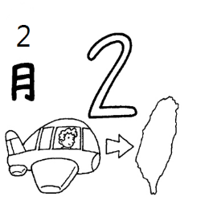 (B)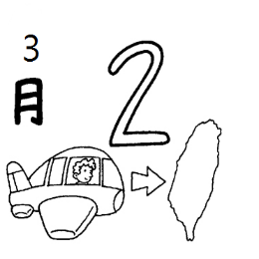 (C)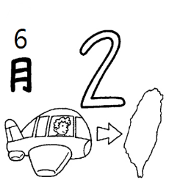
2. (A)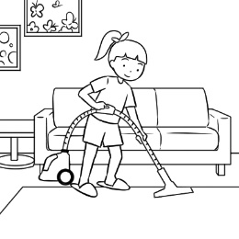 (B)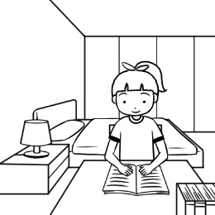 (C)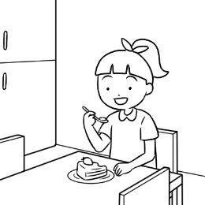
3. ＿＿＿  
   (A)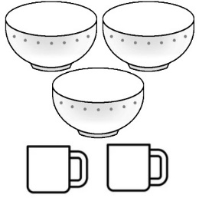 (B)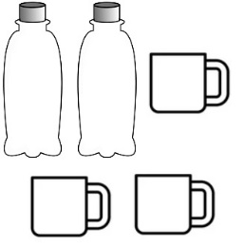 (C)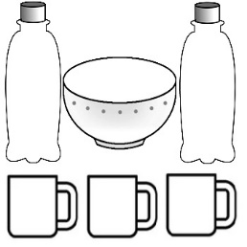
4. ＿＿＿  
   (A)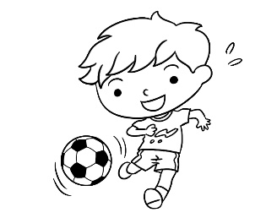 (B)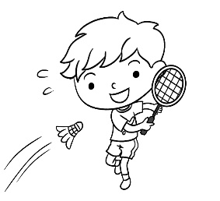 (C)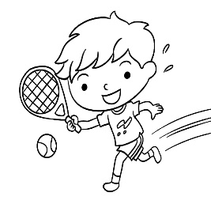
5. ＿＿＿  
   (A)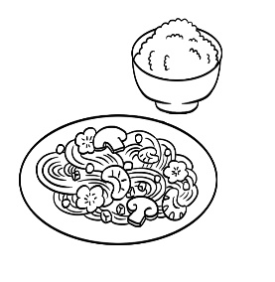 (B)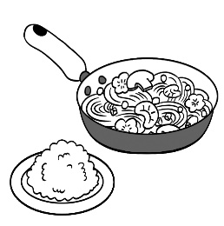 (C)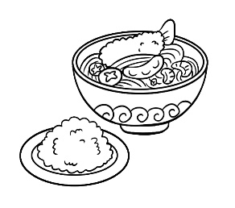

**二、基本問答：每題均有三個選項，請依據所聽到的內容，選出一個最適合的回應。**

1. (A) No, it’s not mine. (B) It’s Danny’s. (C) Yes, that is yours.
2. (A) No, it’s in April. (B) No, it’s on May fifth. (C) No, it’s at 4:30.
3. ＿＿＿  
   (A) I have three. Red, blue, and brown. (B) I have three. Juice, milk, and water.(C) I have three. Chinese, math, and PE.
4. ＿＿＿  
   (A) I like both. (B) They’re both thirsty. (C) I don’t like strawberries.
5. ＿＿＿  
   (A) I have three bags. (B) I’m making fruit pancakes. (C) Three bags of flour, please.

**三、言談理解：每題均有三個選項，請依據所聽到的對話與問題，選出一個最適當的答案。**

1. (A) It’s the boy’s. (B) It’s the girl’s. (C) It’s the boy and the girl’s dad’s.
2. (A) In September. (B) In October. (C) In November.
3. ＿＿＿  
   (A) At a party. (B) In the garden. (C) In the kitchen.
4. ＿＿＿  
   (A) Two bowls. (B) Two bags. (C) She doesn’t need any rice.
5. ＿＿＿  
   (A) Rice. (B) Burgers（漢堡）. (C) Noodles.

**B 綜合測驗 (共50分) (16 --- 35每題2分；36 --- 45 每題1分)**

1. 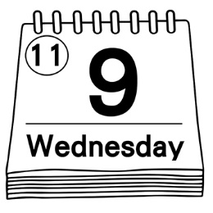What is the date today?
2. It is November ninth.
3. It is on nine eleventh.
4. It is Wednesday.
5. It is December nine.
6. The students in Taiwan are ________ doing their homework every day.
7. easy (B) busy (C) round (D) ready
8. There are ________ floors in this building, and John lives on ________ floor.
9. thirty-five; thirty-fifth (B) thirty-fifth; thirty-five

(C) thirty-five; the thirty-fifth (D) thirty-five; the thirty-five

1. Thanksgiving(感恩節) is ________ the fourth Thursday of November in the USA.
2. with (B) to (C) in (D) on
3. Father: Where is our daughter? I can’t see her.

Mother: Look! She is ________ girl in the line.

1. first (B) the first (C) one (D) the one
2. Bella’s hair is long, ________ mine ________ short.
3. and; are (B) and; is (C) but; are (D) but; is
4. Lorna: ________ is Christmas?

Cinday: It’s on December twenty-fifth.

1. When (B) What time (C) What day (D) How
2. Which does Mary want, ________ or ________?
3. apple; orange (B) apples; oranges (C) a apple; an orange (D) apples; orange
4. In Taiwan, Father’s Day is ________ August, not ________ June.
5. on; on (B) in; on (C) in; at (D) in; in
6. Dad: What time does Ken go to bed every night?

Mon: He ________ to bed ________.

1. go; in June (B) goes; ten o’clock (C) go; on ten (D) goes: at ten
2. Teacher：＿＿＿ guitar is this?

John: It’s ＿＿＿. I borrowed（借）it from him.  
(A) Whose; my brother　 (B) Who; mine (C) Whose; Mike’s　 (D) Whose; that girl’s

1. Frank: Let’s buy some drinks. What do you like?  
   Lisa: I like 　　　 cola.
2. a bowl of　 (B) a can of　 (C) a piece of　 (D) a plate of
3. Peter: ________ is a train ticket for kids under 7 years old from Taichung (台中) to Taipei?

Anna: It’s $218 dollars.

1. How often (B) How long (C) How much (D) How many
2. Leo: ________ fish do you need?

Ivy: I need about ten fish.

1. What (B) Which (C) How much (D) How many
2. Mom: You can’t play video games ________ you finish (完成)your homework.

Son: Yes, Mom.

1. and (B) until (C) or (D) but
2. Mike: Where is my English homework?

Amy: ________ You put it under your chair.

Mike: Thank you very much.

1. What can I do for you? (B) You are right. (C) Here you are. (D) Here we are.

|  |
| --- |
| There are many interesting activities(活動) in different countries(國家). These activities are held (舉辦) at different time.  According to(根據) the information（資訊）from figure 1 (圖1), answer the following(以下的) questions. |

1.  How many countries are there in the figure 1?
2. Four (B) Eight

(C) Thirteen (D) Two

1. People in Mexico paint their face on ________.
2. Carnevale Di Venezia
3. Brazillian Carnival
4. Songkran
5. Day of The Dead
6. People ________ on Brazillian Carnival from

February ninth to thirteenth in 2020.

1. paint faces (B) have water fights

(C) wear masks (D) sing and dance

1. People in Italy wear masks ________.
2. on February twenty-sixth
3. on February tenth
4. on February seventh
5. from April thriteenth to fifteenth

figure 1

**克漏字（每題1分）**

(In the kitchen)  
Scott: Mother’s (36) birthday is coming, but we don’t have any money to buy a gift for her. What can we do?  
Bella: How about making a birthday cake for her?  
Scott: I don’t know how to make cakes or cookies, but there is one thing for sure.

Bella: What is it then? Haha! I know you love to eat them, but you can’t make them. Am I right?  
Scott: You’re really my cute sister. You know me so well. By the way, (37) do we need for the cake?  
Bella: Some flour, sugar, and eggs.  
Scott: Here we have (38) flour and some sugar, but we don’t have (39) eggs at home.  
Bella: Don’t worry. You have many **goose eggs.**  
Scott: What are you talking about?  
Bella: You don’t like English, and you get bad grades on English tests.  
Scott: That’s very, very funny.

1. (A) first (B) tenth (C) twelfth (D) forty-fifth
2. (A) how (B) which (C) what (D) who
3. (A) a bag of (B) a piece of (C) two bottles of (D) a can of
4. (A) some (B) any (C) much (D) few
5. When Scott gets **goose eggs** on English tests, he gets ________.
6. 100 (B) 85 (C) 60 (D) 0

**閱讀測驗（每題1分）**

|  |
| --- |
| RmEd4 29AhwD 28G29m  **20%off 打八折 popular 受歡迎的 summer 夏天** |

1. The ham and egg sandwich at Ally’s Breakfast is eighty dollars. How much are two ham and egg sandwiches on Saturday?

(Ａ)　NT$160.　 (Ｂ)　NT$120.　 (Ｃ)　NT$.128　 (Ｄ)　NT$80.

**42.** Tony takes his mom to eat at Granny’s Kitchen. What CAN’T they get?

(Ａ)Ham and egg sandwiches.(Ｂ)　Cookies.　 (Ｃ)　Orange tea.　 (Ｄ)　Cake.

**43**. Today is May 12th. Alex goes to Super Drink to eat ice cream, but the shop isn’t open. What day is it?

(Ａ)　It’s Wednesday.　 (Ｂ)　It’s Friday.　 (Ｃ)　It’s Thursday.　 (Ｄ)　It’s Sunday.

**44**. Which is true（正確的）?

(Ａ) People can eat ice cream at Super Drink every day.　 (Ｂ)　People like the orange tea at Granny’s Kitchen.

(Ｃ)　Mary is a cook at Ally’s Breakfast.　 (Ｄ)　Super Drink doesn’t have coffee.

**45.** A scoop of (一球) ice cream at Super Drink is one hundred dollars. It’s a hot summer day. Mom and I have two scoops of ice cream. How much do we save (節省)?

(A) $20 (B) $10 (C) $30 (D) $100

**C. 手寫題（共20分），以下題目必須用黑色原子筆作答，否則，零分計算。**

**一．**中翻英 每題1分

1. 水 2. 困難的 (d__) 3. 足夠的 4. 三月 5. 一月

6. 家事 7. 洗碗盤 8. 月 9. 美味的 (d__) 10. 步驟

二． 改寫句子 每題2分

1. They are my brother’s robots. (依劃線部分造原問句)

2. I drink two cups of coffee every day. (依劃線部分造原問句)

三． 引導式翻譯 每格1分

1. 爸爸真地每天把我照顧的很好。

Dad really (1)________good (2)________ (3)________ me every day.

2. A: 你喜歡吃哪一個，檸檬派或草莓鬆餅?

B: 我兩個都喜歡。

A: Which do you like to eat , lemon (4)________ or strawberry(5)________?

B: I like (6)________.

**~~ END ~~**