桃園市立大有國民中學108學年度第一學期第二次評量試卷
年 級 | 八 | 考 試  科 目 | 英語科 |  |  | 命 題  範 圍 | Unit Four- Review Two | 作 答  時 間 | 45分
班級 |  | 姓 名 |  | 座 號 |  | 分 數
- 辨識句意：根據聽到的內容，選出符合描述的圖片或符合圖片的描述。每題2分
1.
(A) | 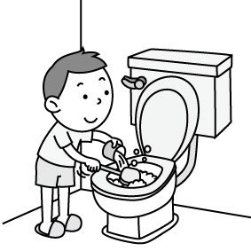 | (B) | 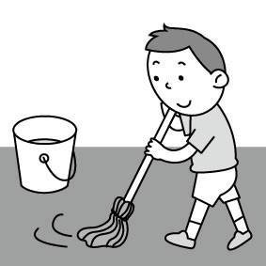 | (C) | 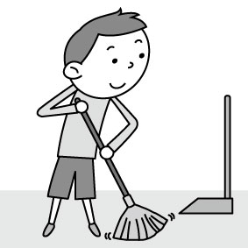
2.
(A) | 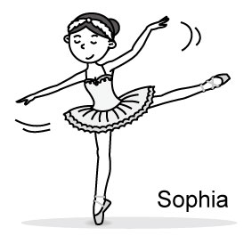 | (B) | 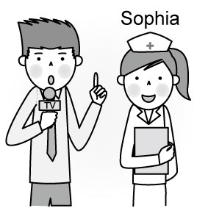 | (C) | 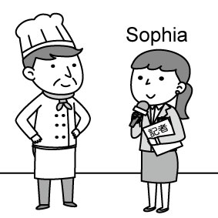
3.
(A) | 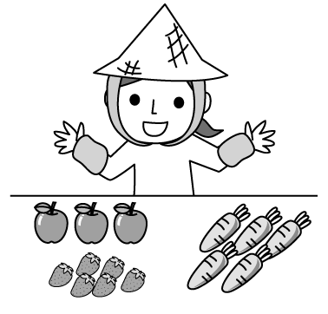 | (B) | 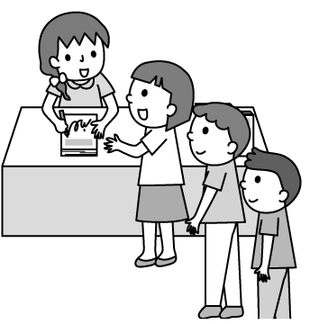 | (C) | 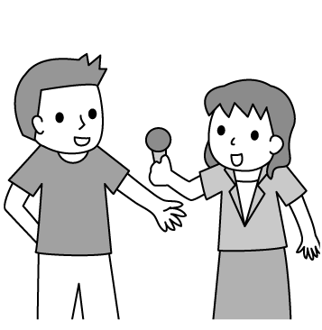
4.
(A) | 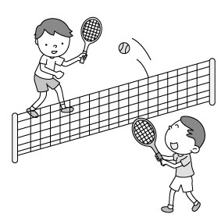 | (B) | 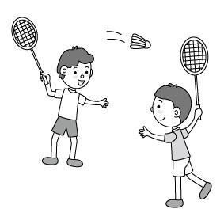 | (C) | 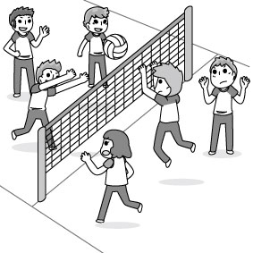
5.
(A) | 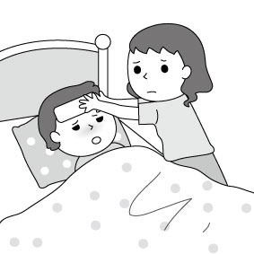 | (B) | 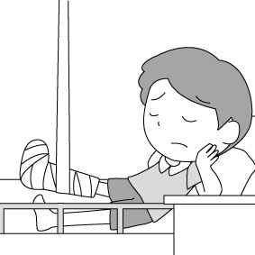 | (C) | 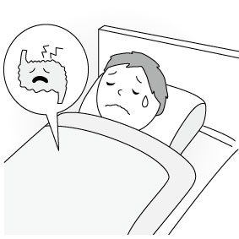
- 基本問答：根據聽到的內容，選出一個最適合的回應或最適合的問句。每題2分
6.(A) He exercises every day.
(B) He doesn’t have good eating habits.
(C) Not so good. The doctor told him to stay in the hospital.
7.(A) Doing math homework is interesting to me.
(B) I was a little sick after school and I took a rest.
(C) Mom, I hate to go to the math class on weekends.
8.(A) I can teach you.
(B) I hate watching TV.
(C) I like to sing karaoke.
9.(A) I study in Taipei.
(B) I want to be a teacher.
(C) I love to dance.
10. (A) The watch is mine. I wore it at dinner.
(B) I found a watch under the sofa. Is it Mark’s?
(C) I didn’t see it. It may be somewhere in the kitchen.
- 言談理解：根據聽到的內容，選出一個最適合的答案。每題2分
11. (A) An actor.
(B) A mail carrier.
(C) A TV reporter.
12. (A) They enjoy sleeping.
(B) They enjoy playing basketball.
(C) They enjoy reading comic books.
13.(A) Tracy’s class starts at eight twenty.
(B) Tracy slept well last night.
(C) Tracy’s dad will drive her to school.
14.(A) Judy couldn’t find her pink watch.
(B) Kevin took Judy’s watch away this morning.
(C) Judy last put her watch on her bed.
15. (A) He was reading a book.
(B) He was watering the flowers.
(C) He was doing the housework with his mother.
四、文法測驗 每題2分
16. Julia ________ lunch with her parents at one o’clock yesterday afternoon.
(A) were eating (B) ate (C) was eating (D) was ate

17. Mark wants ________ a great basketball player like James in the future, so he practices ________ basketball every day.
(A) being ; playing (B) to be; playing (C)to being; to play (D) be; play

18. I am very sorry for ________ late for school today. Can you give me one more chance?
(A) X (B) be (C) to be (D) being

19. It is very nice of you ________ me your English notebook, so I can pass the test.
(A) lend (B) to lend (C) lending (D) to lending

20. It ________ to sing and dance with my friends.
(A) is fun (B) are fun (C) has fun (D) have fun

21. After school, Jack always enjoys ________ his smartphone. But it isn’t good for his eyes.
(A) uses (B) use (C) to use (D) using

22. It’s eleven o’clock. ________ to bed right now, Jack. It is very important for you________ enough sleep.
(A) To go; have (B) Go; to have (C)To go; to have (D) Go; have

23. Jane: Who ________ beef noodles at that time?
Kevin: Mary and George________.
(A) was having; were (B) had; did (C)were having; were (D) was having; was

24. Jack likes ________ Mayday’s songs very much, so he plans ________ to the concert in Taoyuan in December.
(A)listening to; going (B)to listen; to go (C)listen to; going (D) listening to; to go

25. Lisa ________ to have more water because she catches a bad cold.
(A)keeps (B) wants (C) enjoys (D) practices

26. Julia at ten fifty last night, but her sister at that time.
(A)was getting home; was sleeping (B)was getting home;slept
(C) got home; was sleeping (D) got home; slept

27. Reading books very good for students.
(A) is (B) are (C) does (D)do

28. The English test is coming. Let’s stop and prepare for it.
(A) to play (B) play (C) playing (D) to playing

29. Hank kept with friends online yesterday, so he didn’t do his homework.
(A) talking (B) to talk (C) to talking (D) talked

30. Ken had a stomachache .
(A)because had too many moon cakes (B) because to have too many moon cakes
(C) because of had too many moon cakes (D) because of having too many moon cakes

五、克漏字測驗 每題2分
It is very important 31. students 31. go to school every day. They can learn a lot of knowledge in class. During the break, they can talk and play with their classmates. After school, they can also join some school teams and school clubs, like the basketball team, the guitar club or the chess club.
However, Kevin, a junior high school student, doesn’t go to school for many days. When his mom wakes him up, he often says his foot 32. , so he can’t walk to school. Sometimes, he may tell his mom that he has a stomachache, so he still has to stay in bed to take a rest.
His teacher 33. him, and visits him twice a week. Last Monday, he talked with him and asked him: “Why are you 34. to school? Are the subjects too difficult for you? Do your classmates bully you?” He answered “No.” and he told the teacher that he would go to school the next day.
A week went by, but he still didn’t come to school. Nobody knows what to do to help him.

31. (A) for; to (B) of; to (C) to; X (D) for; for
32. (A) hurt (B) hurts (C) gets hurt (D) is hurt
33. (A) worry about (B) is worried about (C) is worried (D) worry
34. (A) scare of going (B) scared of go (C) scare to go (D)scared of going
六、閱讀測驗 每題2分
(35.-37.)
(Kevin is in the hospital.)
Dr. Lee: What’s wrong with you?
Kevin: Ouch. I have a terrible toothache, and I couldn’ t sleep well. I even can’t say anything.
Dr. Lee: Let me check out. Does this hurt?
Kevin: Sure. Don’t touch that.
Dr. Lee: It looks terrible. Do you brush your teeth every day?
Kevin: No, I don’t have time. I’m busy doing my housework.
Dr. Lee: Come on! You should do it every day. By the way, do you eat candy before you sleep?
Kevin: Candy is my favorite. I usually eat two bags of candy every day.
Dr. Lee: That’s too bad. You shouldn’t eat too much candy. Besides, don’t forget to brush your
teeth before you sleep every day.
Kevin: No problem.

35. Why is Kevin in the hospital?
(A) He has a fever. (B) He has a toothache.
(C) He has a sore throat. (D) He has a stomachache.

36. What does Kevin need to do?
(A) He needs to have more candy. (B) He needs to brush his teeth.
(C) He needs to close his mouth. (D) He needs to sleep now.

37.Which is “TRUE” about the reading?
(A) Kevin didn’t sleep well for a long time. (B) Dr. Lee isn’t good at solving Kevin’s problem.
(C) Kevin has a lot of candy every day. (D) Dr. Lee doesn’t want to give Kevin any help.

(38.-40.)
Salmon are large river and sea fish. They begin to swim toward the sea after they are hatched in upper creeks or rivers. On their way there, they get stronger. Salmon spend most of their lives in the sea. It’s the best place to grow because there is a lot of food.
Having grown up, salmon swim back to their birth place thousands of kilometers away. They swim up rivers to lay eggs at the same place where they were born. They can still find the very same river years later.
Salmon are good swimmers. When they return to the upper rivers, they have to swim against the current. When they come across falls, they jump high over them.
salmon 鮭魚 hatch孵化 lay 下(蛋) against 與…相反；對抗 current 水流
38. We call salmon river and sea fish because .
(A) they lay eggs in the river and carry them to the sea (B) they like to swim up and down the river (C) they are good swimmers in the river or in the sea (D) they live both in the river and in the sea

39. Why do salmon return to the birth place?
(A) To lay eggs. (B) To enjoy the clean water. (C) To practice swimming. (D)To look for food.

40.Which do we know about the reading?
(A) Salmon can find little food in the sea. (B) Few salmon can swim back to their birth place.
(C) Salmon hate to live with parents. (D) Salmon are good at swimming.

