**桃園市立大有國民中學110學年度第**二**學期第**三**次評量試卷**

|  |  |  |  |  |  |  |  |  |  |
| --- | --- | --- | --- | --- | --- | --- | --- | --- | --- |
| 年 級 | 七 | 考 試  科 目 | 英語科 | | | 命 題  範 圍 | Unit Five- Review III | 作 答  時 間 | 45分 |
| 班級 |  | 姓 名 |  | 座 號 |  | 分 數 |  | | |

# 第一部分：聽力測驗25%

# 辨識句意：根據聽到的內容，選出符合描述的圖片或符合圖片的描述。(每題一分 5%)

1. （　）  
    (Ａ)　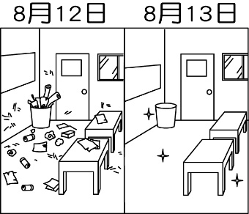(Ｂ)　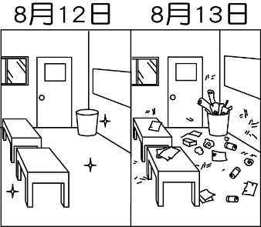(Ｃ)　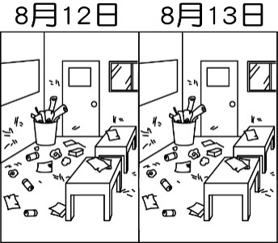
2. （　）  
    (Ａ)　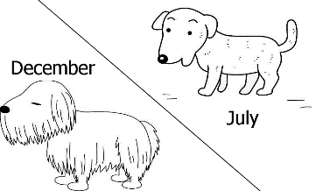(Ｂ)　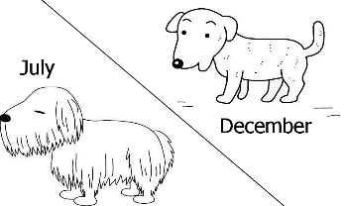(Ｃ)　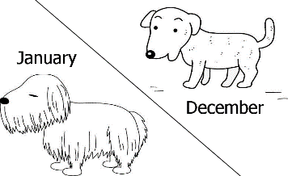
3. （　）  
    (Ａ)　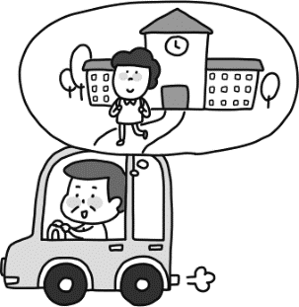(Ｂ)　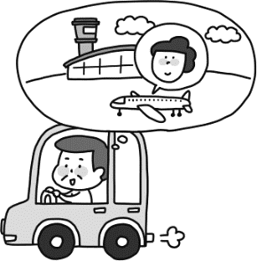(Ｃ)　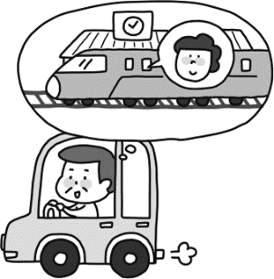
4. （　）  
    (Ａ)　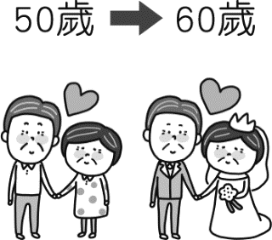(Ｂ)　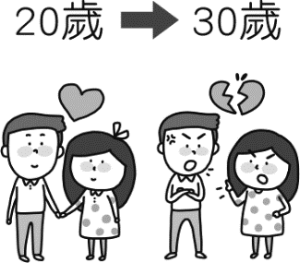(Ｃ)　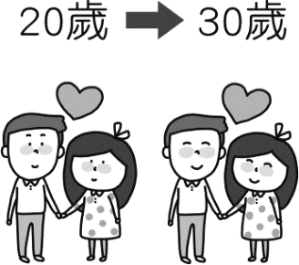
5. （　）  
    (Ａ)　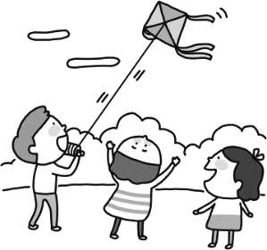(Ｂ)　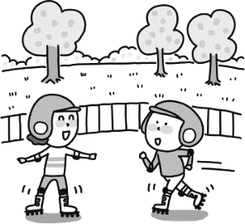(Ｃ)　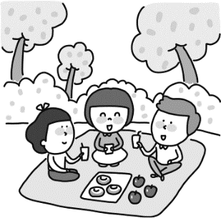

# 基本問答：根據聽到的內容，選出一個最適合的回應或最適合的問句。(每題兩分 10%)

1. （　）(Ａ)　They get into trouble. (Ｂ)　They were watching fish. (Ｃ)　We helped clean the lake.
2. （　）(Ａ)　I was sad at that time. (Ｂ)　At the beach. I was happy. (Ｃ)　I was not at the park with you.
3. （　）(Ａ)　It lasted two hours. (Ｂ)　We went there last week. (Ｃ)　It rained cats and dogs.
4. （　）(Ａ)　No. I don’t need a fork. I can use my right hand.(Ｂ)　No, I don’t really like chicken. (Ｃ)　Chicken rice is very delicious.
5. （　）(Ａ)　I am cooking at home.(Ｂ)　Let’s meet at the train station. (Ｃ)　I stayed at my grandma’s house in the mountain.

# 言談理解：根據聽到的內容，選出一個最適合的答案。(每題兩分 10%)

1. （　）(Ａ)　He doesn’t know what the woman.  
    (Ｂ)　He wants the woman to read the sentence again.  
    (Ｃ)　He agrees with the woman.
2. （　）(Ａ)　The man’s wife went to Tina’s party yesterday.  
    (Ｂ)　The man’s wife was a beautiful singer.  
    (Ｃ)　The woman was at Tina’s party with the man.
3. （　）(Ａ)　He doesn’t want to eat any food.(Ｂ)　He doesn’t like India. (Ｃ)　He doesn’t need to see the doctor.
4. （　）(Ａ)　He is in a hospital. (Ｂ)　He is in a movie theater. (Ｃ)　He is at home.
5. （　）(Ａ)　The streets are dirty. (Ｂ)　There are only a few people in the city.(Ｃ)　The traffic is so bad.

**第二部分：閱讀理解75%**

**一、文法與字彙**：**每題三分 45%**

|  |  |  |  |  |  |  |  |  |  |  |  |  |  |  |  |  |  |  |  |  |  |  |  |  |  |  |  |  |  |  |  |  |  |  |
| --- | --- | --- | --- | --- | --- | --- | --- | --- | --- | --- | --- | --- | --- | --- | --- | --- | --- | --- | --- | --- | --- | --- | --- | --- | --- | --- | --- | --- | --- | --- | --- | --- | --- | --- |
| ( ) | 16. | Amy read the book, *Harry Potter*, the next day, and her brother _______, too. | | | | | | | | | | | | | | | | | | | | | | | | | | | | | | | | |
|  |  | (A) | | did | | | | (B) | | | | | | read | | | | (C) | | | | was | | | | | | | | (D) | | | does | |
| ( ) | 17. | A: _________ you late for school yesterday? B: No, I _________ go to school late yesterday. | | | | | | | | | | | | | | | | | | | | | | | | | | | | | | | | |
|  |  | (A) | | Did；didn’t | | | | (B) | | | | | | Were；wasn’t | | | | (C) | | | | Didn’t；wasn’t | | | | | | | | (D) | | | Weren’t；didn’t | |
| ( ) | 18. | There _________ many fish in the river before, but now there _________. | | | | | | | | | | | | | | | | | | | | | | | | | | | | | | | | |
|  |  | (A) | | had；haven’t | | | | (B) | | | | | | was；isn’t | | | | (C) | | | | were；aren’t | | | | | | | | (D) | | | had；don’t | |
| ( ) | 19. | A: The movie theater is not far from here. How about seeing the movies? B: __________ | | | | | | | | | | | | | | | | | | | | | | | | | | | | | | | | |
|  |  | (A) | | That’s a long way. | | | | (B) | | | | The movie is great. | | | | (C) | | | | Why not? | | | | (D) | | | The movie theater is really far. | | | | | | | |
| ( ) | 20. | I cleaned the house ___________. | | | | | | | | | | | | | | | | | | | | | | | | | | | | | | | | |
|  |  | (A) | | two days before | (B) | | | | | on last weekend | | | | | | | | (C) | | | | the other day | | | | (D) | | | | | | in yesterday morning | | |
| ( ) | 21. | They didn’t go out _________ the weather was bad. | | | | | | | | | | | | | | | | | | | | | | | | | | | | | | | | |
|  |  | (A) | | but | | | | (B) | | | | | | because | | | | (C) | | | | ,so | | | | | | | | (D) | | | x | |
| ( ) | 22. | A: Why didn’t you come to school last week? B: _____________ | | | | | | | | | | | | | | | | | | | | | | | | | | | | | | | | |
|  |  | (A) | | I rode my bike to school last week. | | | | | | | | | | | | | | | (B) | | | | I fell off the stairs and broke my leg. | | | | | | | | | | | |
|  |  | (C) | | I can’t go to school because I am sick. | | | | | | | | | | | | | | | (D) | | | | I went to school with my brother. | | | | | | | | | | | |
| ( ) | 23. | Tom _______ his money from his wife, so she was angry. | | | | | | | | | | | | | | | | | | | | | | | | | | | | | | | | |
|  |  | (A) | | sold | | | | (B) | | | | | | bought | | | | (C) | | | | lost | | | | | | | | (D) | | | hid | |
| ( ) | 24. | The concert ________ night _________ for three hours. How wonderful! | | | | | | | | | | | | | | | | | | | | | | | | | | | | | | | | |
|  |  | (A) | | yesterday；lasted | | | | (B) | | | | | | last；lasted | | | | (C) | | | | lasted；last | | | | | | (D) | | | | | yesterday；last | |
| ( ) | 25. | There are ________ cookies and _________ candy on the table. You can eat some before dinner if you are hungry. | | | | | | | | | | | | | | | | | | | | | | | | | | | | | | | | |
|  |  | (A) | | a few；a few | | | | (B) | | | | | | a few；a little | | | | (C) | | | | a little；a little | | | | | | | | (D) | | | a little；a few | |
| ( ) | 26. | A: I had to stay home this week. B: _______________ A: My parents got COVID-19. | | | | | | | | | | | | | | | | | | | | | | | | | | | | | | | | |
|  |  | (A) | | Why not? | | | (B) | | | | | | What happened? | | | | | (C) | | | | You know what? | | | | | | | | | | (D) | | Come on! |
| ( ) | 27. | A: ____________________ B: I was with my cousin. | | | | | | | | | | | | | | | | | | | | | | | | | | | | | | | | |
|  |  | (A) | How were you ? | | (B) | | | | Where were you? | | | | | | (C) | Who were you with? | | | | | | | | | (D) | | | | Where was your cousin? | | | | | |
| ( ) | 28. | A: Tom’s house was on fire yesterday. B: Oh, my god! Is he ok?  A: _________________ He almost died. | | | | | | | | | | | | | | | | | | | | | | | | | | | | | | | | |
|  |  | (A) | | He is ok now, but the fire almost took his life. | | | | | | | | | | | | | | (B) | | | | The fire was so big, and it took his life. | | | | | | | | | | | | |
|  |  | (C) | | He was not at his house then. | | | | | | | | | | | | | | (D) | | | | The fire was so small, so he is ok now. | | | | | | | | | | | | |
| ( ) | 29. | A: Look! The dog ____________ after Tom. B: It’s a crazy dog. It __________ after me last weekend. | | | | | | | | | | | | | | | | | | | | | | | | | | | | | | | | |
|  |  | (A) | runs；ran | | | (B) | | | | | | is running；ran | | | | | (C) | | | | is run；was run | | | | | | | | | | (D) | | ran；ran | |
| ( ) | 30. | A: Tom, ________ the room now. B: I ________, and it’s clean now. | | | | | | | | | | | | | | | | | | | | | | | | | | | | | | | | |
|  |  | (A) | is cleaning；did | | | (B) | | | | | cleans；did | | | | | | (C) | | | | clean；did | | | | | | | | | | (D) | | clean；do | |

**三、克漏字 每題兩分 12%**

|  |  |  |  |  |  |  |  |  |  |
| --- | --- | --- | --- | --- | --- | --- | --- | --- | --- |
| Amy: ______(31)_____? Mary ___(32)____ married last week.  Tom: What? ___(33)___ she just ___(34)___ in love with her boyfriend a month ago?  Amy: Yeah! ____(35)_____ they planned to spend their honey moon in India.  Tom: Are they going to the Taj Mahal? The building is famous __(36)__ its love story.  Amy: That’s right. So romantic, isn’t it? | | | | | | | | | |
| ( ) | 31. | (A) | You know what | (B) | Why not | (C) | How come | (D) | Really |
| ( ) | 32. | (A) | get | (B) | gets | (C) | got | (D) | getting |
| ( ) | 33. | (A) | Didn’t | (B) | Wasn’t | (C) | Doesn’t | (D) | Isn’t |
| ( ) | 34. | (A) | fall | (B) | feel | (C) | fell | (D) | felt |
| ( ) | 35. | (A) | So | (B) | But | (C) | Because | (D) | Besides, |
| ( ) | 36. | (A) | as | (B) | for | (C) | of | (D) | from |

**四、閱讀測驗 每題兩分，18%**

**1. Can You Spot More Words?**

How many words can you find in one word? You can use any of the letters in a word to make a new word. Let’s look at the following example(例子). The example word is “pictures.”

**CURE**

**IT**

**PIECE**

**TIP**

**example**



**(pictures)**

**(pictures)**

**(pictures)**

**(pictures)**

[Related image](https://www.google.com/url?sa=i&source=images&cd=&ved=2ahUKEwiWx8DB9uviAhUVzIsBHT86BEIQjRx6BAgBEAU&url=https://en.wikipedia.org/wiki/File:Check_mark_9x9.svg&psig=AOvVaw1pcXXMdaoOv9JgoAjuv_02&ust=1560703115575219)

**pictures**

[Related image](https://www.google.com/url?sa=i&source=images&cd=&ved=2ahUKEwiH4d2K9-viAhWSHKYKHTe6BjAQjRx6BAgBEAU&url=https://en.m.wikipedia.org/wiki/File:Dario.svg&psig=AOvVaw0vfeUWKTEdMOi_3E25PQKX&ust=1560703316297805)[Related image](https://www.google.com/url?sa=i&source=images&cd=&ved=2ahUKEwiWx8DB9uviAhUVzIsBHT86BEIQjRx6BAgBEAU&url=https://en.wikipedia.org/wiki/File:Check_mark_9x9.svg&psig=AOvVaw1pcXXMdaoOv9JgoAjuv_02&ust=1560703115575219)[Image result for cross wrong](https://www.google.com/url?sa=i&source=images&cd=&ved=2ahUKEwjXo5319uviAhXFyosBHbaNCuUQjRx6BAgBEAU&url=http://pluspng.com/png-wrong-cross-2223.html&psig=AOvVaw2Les3NKMNaNcvTNTf1YhLd&ust=1560703276610523)[Related image](https://www.google.com/url?sa=i&source=images&cd=&ved=2ahUKEwiWx8DB9uviAhUVzIsBHT86BEIQjRx6BAgBEAU&url=https://en.wikipedia.org/wiki/File:Check_mark_9x9.svg&psig=AOvVaw1pcXXMdaoOv9JgoAjuv_02&ust=1560703115575219)

**3 points**

**0 point**

**4 points**

**2 points**

**Hana: theater**

**1st**

**Maruko: rest**

**Lan: ANT**

**Yuki: AT**



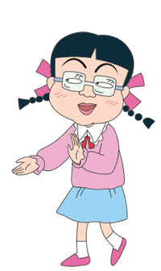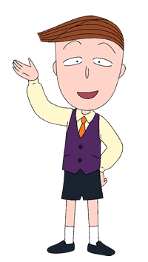

**restaurants**



|  |  |  |  |  |  |  |  |  |  |
| --- | --- | --- | --- | --- | --- | --- | --- | --- | --- |
| ( ) | 37. | Who can’t win any point in the first round? | | | | | | | |
|  |  | (A) | Maruko | (B) | Yuki | (C) | Lan | (D) | Hana |
| ( ) | 38. | Who can win the first round? | | | | | | | |
|  |  | (A) | Maruko | (B) | Yuki | (C) | Lan | (D) | Hana |
| ( ) | 39. | If you want to win in the first round, what word can you make? | | | | | | | |
|  |  | (A) | restroom | (B) | train | (C) | test | (D) | stars |
| ( ) | 40. | These 4 students have “TRAIN”, “FEAR”, “FAIR”, and “NEAR” for the second round, and they all can win some points. What can be the word from the teacher? | | | | | | | |
|  |  | (A) | restaurant | (B) | relative | (C) | rainforest | (D) | restroom |

**2. Wild Fashion in Tokyo**

|  |  |  |  |  |  |
| --- | --- | --- | --- | --- | --- |
| When I was in Tokyo, I learned that people are really serious(認真) about fashion(時尚) there. They even have some wild fashion cultures(文化). If you want to be a part of them, you need to have the right look.  I met a group of girls in Harajuku(原宿). Their clothes were every color in the rainbow(彩虹). They all had a lot of clips(髮夾) in their hair. Some wore stickers(貼紙) on their faces.  They said that they were Decora style. It makes their lives more fun.  Some other girls carried cute umbrellas and purses(皮包). They had big skirts, long socks and bows(蝴蝶結) in their hair. They said that they were Lolita style. I thought they look like pretty dolls.  In Yoyogi Park(代代木公園), some men and women danced to old music. They had black leather(皮革) jackets and big hairstyles. It was a rockabilly party. They said they do this every weekend.  People in Tokyo put a lot of work into their looks. | | | | | |
| ( ) | 41. | Which style is close to Lolita style? | | | |
|  |  | (A) |  | (B) |  |
|  |  | (C) |  | (D) |  |
| ( ) | 42. | Who may(可能) want to join the rockabilly party? | | | |
|  |  | (A) | Amy. She likes to read comic books, and cosplays(角色扮演) as comic book characters.(人物) | | |
|  |  | (B) | Anne. She likes Disney characters a lot, and she often dresses like a princess. | | |
|  |  | (C) | Tom. He likes fiction(科幻) movies, like Harry Potter. | | |
|  |  | (D) | John. He likes old rock songs, and his favorite singer is Elvis(貓王). | | |

**3. Swimming Is Good for Your Health**

Anne wrote a report about the benefits(好處) of swimming last week. Here are some facts in her report.

**Fact 1 :**

Swimming burns calories(卡路里). The amount(數量) of calories burned in ten minutes depends on(取決於) the swimming style.

|  |  |  |  |  |
| --- | --- | --- | --- | --- |
| Swimming styles | Backstroke(仰式) | Freestyle | Breaststroke(蛙式) | Butterfly |
| Calories burned | 86 calories | 127 calories | 122 calories | 135 calories |

**Fact 2 :**

Swimming makes you happy. After you swim for twenty minutes, your brain(腦袋) starts to make endorphins, and they put you in a good mood.

**Fact 3 :**

If you can swim for thirty minutes, it can cut the chances of heart disease(疾病) and diabetes(糖尿病).

**Fact 4 :**

It makes you strong. Swimming can train your muscles(肌肉), increase(增加) your flexibility(彈性), and it’s good for your bone health. It also has the least(最低的) risk of injury(受傷) of any sport.

|  |  |  |  |  |  |  |  |
| --- | --- | --- | --- | --- | --- | --- | --- |
| ( ) | 43. | What can endorphins do to your body? | | | | | |
|  |  | (A) | It can make you strong. | (B) | It can lower health risks. | | |
|  |  | (C) | It can keep you happy. | (D) | It can keep you from danger. | | |
| ( ) | 44. | Which benefit of swimming is not mentioned(提到) in the reading? | | | | | |
|  |  | (A) | It makes your muscles strong and increase your flexibility. | | | (B) | It can put people in a good mood. |
|  |  | (C) | People are not easy to get hurt while(當… )swimming. | | | (D) | It can cure(治好) heart disease and diabetes. |
| ( ) | 45. | Here is the schedule of our swimming teacher, Sally. Which is the right picture of the loss of calories for Sally?   |  |  |  |  |  |  | | --- | --- | --- | --- | --- | --- | |  | Monday | Tuesday | Wednesday | Thursday | Friday | | 9:30-10:30 | Backstroke |  |  | Breaststroke |  | | 10:40-11:40 |  | Freestyle |  |  | Free Style | | 13:30-14:30 |  |  |  |  | Backstroke Style | | 14:40-15:40 |  |  | Butterfly | Butterfly Style |  | | | | | | |
|  |  | (A) |  | | | (B) |  |
|  |  |  |  | | | | |
|  |  | (C) |  | | | (D) |  |