桃園市立大有國民中學110學年度第二學期第一次評量試卷
年 級 | 七 | 考 試  科 目 | 英語 |  |  | 命 題  範 圍 | Unit 1~Review1 | 作 答  時 間 | 45分
班 級 |  | 姓 名 |  | 座 號 |  | 分 數

A. 聽力測驗，每題2分，共30分。

一、辨識句意：根據聽到的內容，選出符合描述的圖片或符合圖片的描述。
1. (A)  | (B) 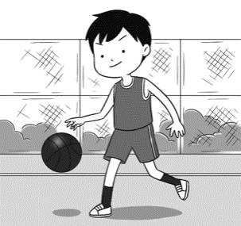 | (C) 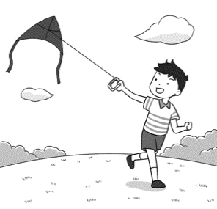
2. (A) 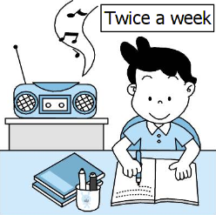 | (B) 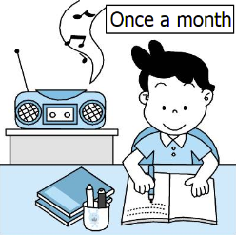 | (C) 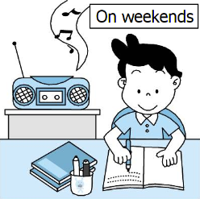
3. (A) 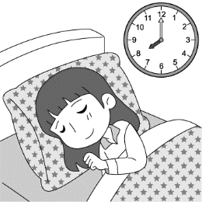 | (B) 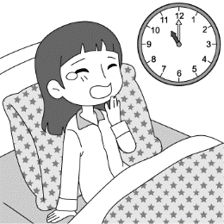 | (C)  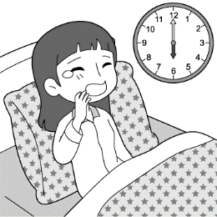

二、基本問答：根據聽到的內容，選出一個最適合的回應或最適合的問句。
4. (A) I’m one hundred and sixty. | (B) I’m very tall. | (C) Not bad.
5. (A) She has much free time. | (B) She plays the piano at home. | (C) Yes, she plays the guitar very well.
6. (A) Sorry, but I have to do my homework. | (B) Yes, I like the book so much. | (C) He can play the guitar, too.
7. (A) Yes, I want a lot of exercises. | (B) Twice a day. | (C) It’s healthy for me.
8.(A) He is a good player. | (B) He plays tennis. | (C) I don’t go there every day.
9.(A) He has nice hair, too. | (B) I don’t have blue eyes. | (C) Yes, you are very handsome.

三、言談理解：根據聽到的內容，選出一個最適合的答案。
10. (A) The USA. | (B) England. | (C) Japan.
11. (A) Go to the cram school. | (B) Do some homework. | (C) Swimming with his friends.
12. (A) Twice a week. | (B) Twice a year. | (C) Once a year.
13. (A) Play balls with David. | (B) Jump rope. | (C) Swim.
14. (A) They don’t really like the restaurant. | (B) The price is very high in the Japanese restaurant. | (C) Sam goes to the restaurant almost every day.
15. (A) Play frisbee. | (B) Feed the fish. | (C) Listen to music.

B. 綜合測驗，共50分。
四、文法測驗 (第16-28題，每題2分)
16. Jack math, but I don’t like it.
(A) like (B) don’t like (C) doesn’t like (D) likes
17. A: What Lily in the mornings? B: She jogs in the mornings.
(A) does; does (B) does ; do (C) is ; doing (D) do ; do
18. A: How often does Maggie feed the cat? B: ＿＿＿ a week.
(A) Five time (B) Five (C) Five times (D) Fifth
19. The sofa in the living room is big. The boys ＿＿＿ on it.
(A) usually sleep (B) sleep usually (C) sometimes sleeps (D) sleeps sometimes
20. A: B: She paints or swims.
(A) What can Elsa do? (B) Does Elsa play sports?
(C) Does Elsa have long legs? (D) What does Elsa do on weekends?
21. A: What’s wrong with Ian? He’s late again. B: He’s ＿＿＿ on time.
(A) usually (B) never (C) sometimes (D) often
22. Paul ＿＿＿ basketball from Monday to Friday, and Kevin ＿＿＿ it on weekends.
(A) practices; does (B) doesn’t practice; don’t do
(C) practice; doesn’t do it (D) don’t practice; does
23. My cousins soccer every Sunday.
(A) plays (B) play (C) playing (D) are playing
24. A: Your bedroom clean. Do you often clean it up?
B: Sure. I clean it up every two days.
(A) always is ; seldom (B) is usually ; never (C) is always ; usually (D) never is ; sometimes
25. A: What do do on Sunday mornings? B: They sleep until(直到) lunchtime.
(A) Mom (B) your kids (C) Tina (D) I
26. Betty walks in the park after dinner, and Allen , too.
(A) is (B) does (C) do (D) can
27. A: your dad have a busy life? B: Yes, he .
(A) Do ; has (B) Does ; has (C) Do ; does (D) Does ; does
28. Teacher Anna is always busy, but I .
(A) always am (B) am sometimes (C) am never (D) seldom am

五、克漏字 (第29-32題，每題2分)

 | Hi, I’m Emma. I have three good friends. They are Sara, Scott, and Bella. In school, we (1) together, but we do different things after school. Sara (2) to the gym after school. She plays basketball with her mom there. Bella (3) a kite in the park, and she has a good time there. Scott doesn’t play sports after school. He has English classes on Mondays, Wednesdays, and Fridays. On weekends, Scott (4) TV with his father.
29. (A) studies and plays |  | (B) studies and play | (C) study and plays | (D) study and play
30. (A) is going |  | (B) goes | (C) go | (D) doesn’t go
31. (A) flys |  | (B) fly | (C) flies | (D) don’t fly
32. (A) watch |  | (B) is watch | (C) watches | (D) isn’t watch

六、閱讀測驗 (第33-40題，每題2分)
A.
ORANGE NEWS
Monday, March 14, 2022 By Emily Bruce
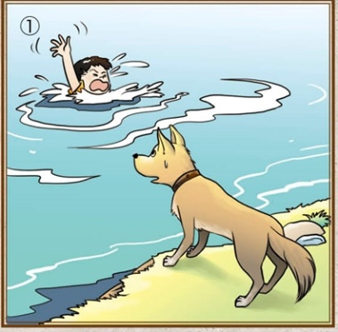
This is Lucky. He is Jimmy’s hero.
Why is Lucky Jimmy’s hero?
Look at Picture One. Can you see Jimmy in the lake?
Jimmy can’t swim! What can he do?



In Picture Two, we can see Lucky, today’s hero! He is a great dog.
He can do a lot of things. Above all, he can swim, so Jimmy is safe.
Jimmy’s mom and dad are very happy about it, and they appreciate
Lucky a lot.

- hero 英雄 lake 湖泊 thing 事 above all 最重要的是 so 所以 safe 安全的

33. Which is the best headline(標題) of the story?
(A) A Dog Can Swim. (B) A Boy’s Cute Dog.
(C) A Dog’s Happy Life. (D) A Hero Dog Saves a Boy.
34. Which is Picture Two?
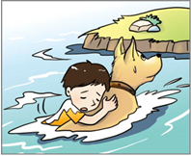  (A) | 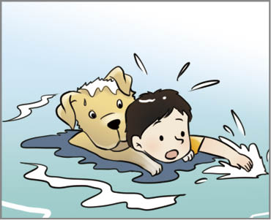  (B) | 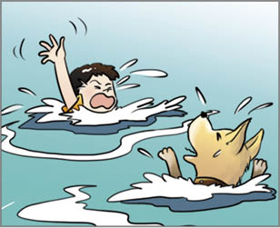  (C) | 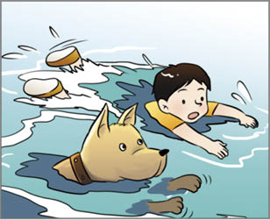  (D)
35. Jimmy’s mom and dad appreciate Lucky. What might they say to him?
(A) "Are you happy?"
(B) "We don’t like you."
(C) "Thank you so much."
(D) "Can you teach Jimmy to swim?"
B.
Dear Ms. Ko,
My sister is heavy, and she’s “on a diet” now. She eats only one meal a day. She doesn’t have lunch or
dinner. Sometimes, she only drinks milk in the morning. Is it enough for her? By the way, she exercises only
once a month. I really worry about her health.
Jason
-------------------------------------------------------------------------------------------------------------------------------------
Dear Jason,
You’re right. Only one meal a day isn’t enough. In fact, it’s a bad idea. I have some advice for your sister.
For example, walk for one hour a day. Exercise three times a week. Don’t eat between meals. That’s not difficult, right?
Kathy Ko
heavy 重的 meal 一餐 health 健康 advice 建議
36. How often does Jason’s sister exercise?
(A) Never. (B) Every day. (C) Once a week. (D) Every four weeks.

37. What should(應該) Jason’s sister do?
(A) Walk for one hour a day.
(B) Eat breakfast only.
(C) Don’t eat dinner.
(D) Eat between meals.

38. Who might be “on a diet”?
(A) Mary. She drinks cola four times a day.
(B) Tim. He eats a lot of pies every day.
(C) Cindy. She eats only salad for lunch and dinner.
(D) Leo. He always has some cake after meals.

C.
Ben is learning from home, so he tries hard to make his own schedule at home.
April
 | SUN | MON | TUE | WED | THU | FRI | SAT
10:00-12:00 | watch TV:  baseball game | class | watch TV:  baseball game | class | watch TV:  baseball game | class | watch TV:  baseball game
13:00-  15:00 | walk the dog | class | class | class | class | walk the dog | use the computer
15:00-  17:00 | use the computer | make a cake | clean the house with Mom | use the computer | make a cake | class | clean the house with Dad
17:00-  18:00 | play baseball |  | class | class |  | walk the dog | play baseball
19:00-  21:00 | save stray dogs | study | walk the dog | study | study | study | save stray dogs
- stray 流浪的
39. What does Ben do four times a week?
(A) Use the computer. (B) Make a cake. (C) Play baseball. (D) Walk the dog.

40. Mom: What is your plan today?
Ben: Oh, it’s a really hard and busy day. I have class from 10 a.m. to 3 p.m.
After that, I do some reading homework on the Net, and then Ms. Li’s math class
is at 5 p.m.
What day is it today?
(A) Wednesday. (B) Thursday. (C) Friday. (D) Saturday.

================================================================================

