**桃園市立大有國民中學112學年度第二學期第二次評量試卷**

|  |  |  |  |  |  |  |  |  |  |
| --- | --- | --- | --- | --- | --- | --- | --- | --- | --- |
| 年 級 | **八** | 考 試  科 目 | **英語科** | | | 命 題  範 圍 | L3~Review 2 | 作 答  時 間 | 45分 |
| 班 級 |  | 姓 名 |  | 座 號 |  | 分 數 |  | | |

**第一部分:聽力測驗 30% (每題兩分)**

**一、辨識句意-根據聽到的內容，選出正確的圖片代碼**：

1. (A)　　　　　 (B)　　　　　 (C)　　　　　  
   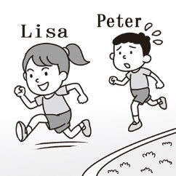 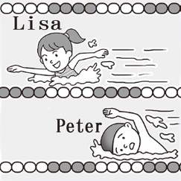 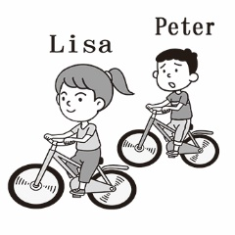
2. (A)　　　　　 (B)　　　　　 (C)　　　　　  
   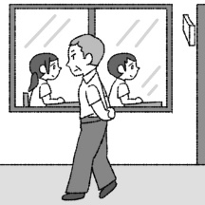 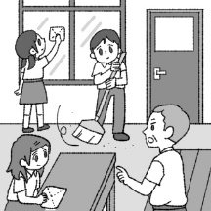 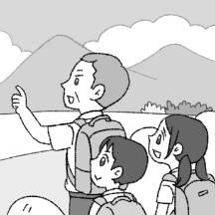
3. (A)　　　　　 (B)　　　　　 (C)　　　　　  
   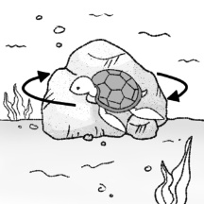 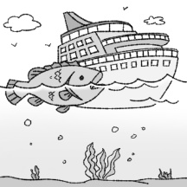 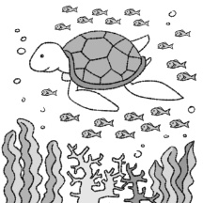
4. (A)　　　　　 (B)　　　　　 (C)　　　　　  
   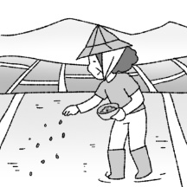 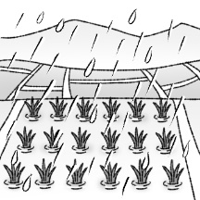 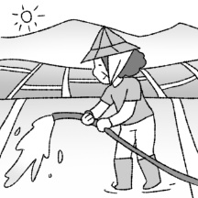
5. (A)　　　　　 (B)　　　　　 (C)　　　　　  
   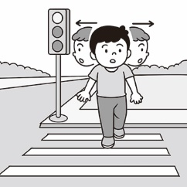 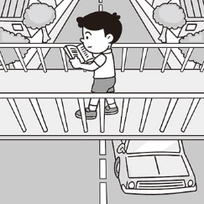 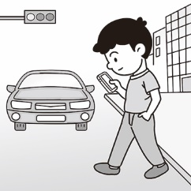
6. **基本問答-根據聽到的內容，選出合適的回應**：

6. (A) My wife bought all of them. (B) Yes. I can’t wait to try them.

(C) Of course, Mrs. Lin gave them to me.

1. (A) Don’t worry. I can let you wear mine. (B) Try to ask your brother to clean them.  
   (C) You may tell Dad to bring them to Mom.
2. (A) I can’t wait to travel to Penghu. (B) Most important of all, you had to take pictures of fish.  
   (C) I had a great time staying with my grandparents.
3. (A) He speaks too fast. (B) I like English class. (C) Yeah, but just a little.
4. (A) Right. It tastes really good. (B) They’re not in season now. (C) Great. Eat more slowly and quietly.
5. **言談理解-根據聽到的對話內容與問題，選出正確的答案**：
6. (A) Cook dinner. (B) Buy some fruits. (C) Make some juice.
7. (A) In a library. (B) In a shoe shop. (C) In a restaurant.
8. (A) He’s eating slowly. (B) He’s eating noisily. (C) He’s eating hungrily.
9. (A) There will be a party tomorrow. (B) Nina will go to the supermarket.  
   (C) The man will make cakes for Nina.
10. (A) The boy likes mangoes. (B) The boy ate some mangoes. (C) The boy bought mangoes yesterday.

**第二部分: 讀寫測驗 70%**

1. It was not easy to go to school on a snowy day because snow _______ the road.

(A ) shone (B) hid (C) blocked (D) tricked

1. Josh is not as careful as his brother. For example, last Sunday, he just_______ his umbrella on the bus.

(A) left (B) caught (C) bought (D) fell

1. This supermarket is very ________ because it usually sells things at a low price. Many people like shopping here.

(A) popular (B) lucky (C) skillful (D) giant

1. My parents ________ me use my phone for only one hour every day.

(A) want (B) need (C) have (D) ask

1. Lucas _________ a pair of gloves for his friend, Jack. Jack liked the gloves very much.

(A) showed (B) made (C) gave (D) sold

1. We have great fruits in Taiwan because Taiwan’s climate is ___________ for growing fruit.
   1. excellent (B) poor (C) several (D) noisy
2. Our teacher told us ________ with classmates. We should respect(尊重) each other.
   1. not fighting (B) not fight (C) didn’t fight (D) not to fight
3. Michael is a hard-working student. He studies math _______ than his classmates.

(A) hard (B) worst (C) harder (D) badly

1. Luke always spends little time on math, so he does the ________ in his class.

(A) worst (B) most (C) best (D) worse

1. Joseph took nice pictures during his tirp in Japan. Maybe he will show __________ next week.

(A) it for you (B) it to you (C) them to you (D) them for you

1. The little girl couldn’t find her parents in the night market. She looked ______ and was crying ______.

(A) sadly; loud (B) sadly; loudly (C) sad; loud (D) sad; loudly

1. Alice jumps ____________ on her team. No other student jumps ________ than her.

(A) high; high (B) the highest; higher (C) high; higher (D) higher; highest

1. Helen’s birthday is coming. Let’s send a card ______ her.

(A) in (B) to (C) for (D) of

29. Dad ________ me to come home early today. We’re going to celebrate Grandma’s birthday.

(A) had (B) lets (C) planned (D) asked

|  |
| --- |
| Tiffany: Jessie! Come and take a look at the new student in our class. He is good at running.  Jessie: Oh! He is really my type. I like his handsome face. Wow! He is running __(30)___ than all the other boys in our class.  Tiffany: Yes, he is going to win the running race. Let’s cheer for him __(31)____. Maybe he will notice us.  Jessie: I’m too shy. I would like to write a note __(32)____ him.  Matt: Are you guys talking about the new student?  Jessie: Yes. Do you know him?  Matt: Yes, he used to __(33)___ my neighbor when I was eight. We were good friends then.  Jessie: My goodness! Please tell me more about him. |

1. (A) more slowly (B) faster (C) the worst (D) carefully
2. (A) loud (B) quietly (C) high (D) crazily
3. (A) to (B) of (C) with (D) in
4. (A)is (B) was (C)be (D) x

|  |
| --- |
| The Internet can help you do a lot of things, but it also can put you in danger. You should protect your personal information when you are online. Here are some of the best ways to do it.   1. Don’t share too much information on social media. You should be careful when posting about where you are, and you should check who can see your posts. 2. Always use strong passwords. Never use your birthday or common words. Those are easy to guess. You should use a mix of small and big letters, numbers, and symbols. 3. Make sure you use the safe websites. When you are entering personal information, make sure the address starts with “https.” This should protect your information. Only open links from safe websites. 4. Be careful with money. Bad people often trick others to get money. They tell sad stories or sell bad things. You can even pay money but get nothing.   #socail media 社群媒體 password密碼 mix混和symbol符號 links 連結 |

1. According to the reading, which of the following is the best password?

(A) 40August2024 (B)Zkd$$bbG29##8 (C)MonicaLin (D)20091021

1. Sally is a student. According to the reading, what should she do to use the Internet wisely?

(A) Chat with someone and speak about her name and school. (B) Donate money to strangers online.

(C) Use her own phone number as the passwords. (D) Be careful when opening the links.

|  |
| --- |
| How much do you know about idioms in English? Using idioms makes you sound like native speakers. So, let’s learn some fun idioms about fruit in English.  *go bananas = to get angry  *the cherry on the cake= to make some good things become even better  *compare apples and oranges= two things are very different, and it’s not smart to compare them  *one bad apple spoils the whole bunch= someone creates problems and make trouble for others  *lemon= a very stupid person  *peach= someone or something excellent or pleasing  *idioms俚語 native speakers 母語人士 spoil 弄壞 bunch 鍋 pleasing 令人愉悅的 |

1. Hurry up! I don’t want to be late. Dad will _________ and shout at us.
2. compare apples and oranges (B) be a lemon (C) go bananas (D) be a peach
3. Which of the following is true?
4. I’m so hungry. May I go bananas right now?
5. Thanks for coming to my birthday party. The gift from you is really the cherry on the cake.
6. Michael always talks to people nicely. He is really a lemon.
7. Matt often helps his classmates with homework. He is surely a bad apple in his class.

|  |
| --- |
| Read the homepage of the Brown Monkey Center and answer the following questions.  **Summer vacation is around the corner.**  **Are you tired of staying at home all day long?**  **Do you want to do something meaningful for nature?**  The members of the center come from all over the world to take care of brown monkeys here in South America. Many brown monkeys used to live here. However, the development of the cities made the poor monkeys lose their natural homes. So, the number of brown monkeys is much lower than it was before. In fact, brown monkeys are in danger of becoming extinct. Please join us to help the poor brown monkeys.  # **What kind of person are we looking for?**  First, you have to love animals. Second, you have to be in good shape because we do a lot of walking and have to carry heavy baskets of food. You also have to be a good team worker because no one works alone here. We work in groups. You will have to share a bedroom with two or three people. And last but not least, you will need to speak English.  **#What will you do every day?**  **#How will you get to the Brown Monkey Center?**  **#How long does the trip take?**  **#How much does the trip cost?**  **\***homepage **網頁**development **發展** extinct **滅絕的** last but not least **最後但一樣重要的** |

38. What can we learn from the reading?

(A) English is the common language in the center.

(B) The work is like going on a vacation (度假) in South America.

(C) You need to pay a lot of money for your own trip to the Brown Monkey Center.

(D) The number of brown monkeys is becoming less and less because people hunt them for food.

39. Which person below is in good shape?

(A) Tom is handsome.

(B) Pete keeps a cute dog.

(C) Mia is healthy and strong.

(D) Ted always eats a lot.

40. Laura is reading the homepage of the Brown Monkey Center.

|  |
| --- |
| You have to work every day from 9 a.m.to 8p.m. The job isn’t easy, but it’s a lot of fun. Every day, you will need to prepare the monkey’s food and feed them. After that, you will have to wash the dishes. You will also need to help clean the center. |

On which part of the homepage can Laura see these words?

1. How long does the trip take?
2. How much does the trip cost?
3. How will you get to the center?
4. What will you do every day?

**桃園市立大有國民中學112學年度第二學期第二次評量試卷**

|  |  |  |  |  |  |  |  |  |  |
| --- | --- | --- | --- | --- | --- | --- | --- | --- | --- |
| 年 級 | **八** | 考 試  科 目 | **英語科** | | | 命 題  範 圍 | L3~Review 2 | 作 答  時 間 | 45分 |
| 班 級 |  | 姓 名 |  | 座 號 |  | 分 數 |  | | |

**\*\*請將答案以黑筆直接填寫在此卷上\*\***

**六、引導式翻譯，請依句意填入適當單字，每格1分，共12分**

**1. 當地震發生的時候，找到某處安全的地方躲藏是很重要的。**

**When the earthquake hits, it is ________________________ to find _______________________ safe to _________________.**

**2. 這個成功的領導者幫助農夫們把西瓜種子賣到國外。**

**The _________________ leader helped farmers sell _____________________ seeds __________________.**

**3. 一些孩子甚至沒有機會可以成長。**

**Some kids won’t even have a _________________________ to _________________ up.**

**4. 媽媽要我留下一些芭樂給我的弟弟。**

**Mom had me _______________________ some _______________________ for my little brother.**

**5.請買一瓶水給我。**

**Please buy a __________________ of water _________________ me.**

**七 請填入副詞或形容詞(含比較級或最高級) 每格1分，共8分**

1. **Tom and Frank are both ___________ cooks. They joined the cooking contest together. However, Tom did not do ____________ on it. Frank cooked the ___________, so he won the contest. ( good )**
2. **Ben did not catch the man because he ran _________________________ than the man.( slow )**
3. **The joke made everyone __________, and May laughed _____________________ of all. (happy)**
4. **The test was really _____________for Liz. She finished it _________________________. ( easy )**