桃園市立大有國民中學110學年度第二學期第三次評量試卷
年 級 | 八 | 考 試  科 目 | 英語科 |  |  | 命 題  範 圍 | Unit Five- Review III | 作 答  時 間 | 45分
班級 |  | 姓 名 |  | 座 號 |  | 分 數

本試卷共6頁，請將答案畫計於答案卡上，違者不予計分!!

辨識句意：根據聽到的內容，選出符合描述的圖片或符合圖片的描述。每題1分
1.
(A) |  | 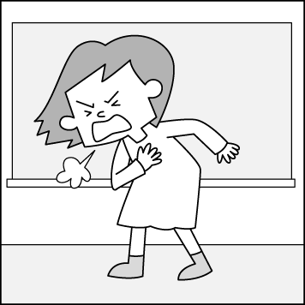 |  | (B) |  | 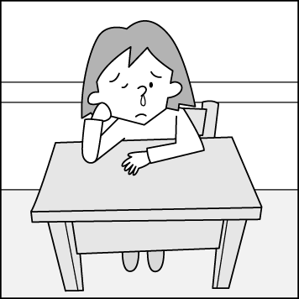 | (C) |  |  | 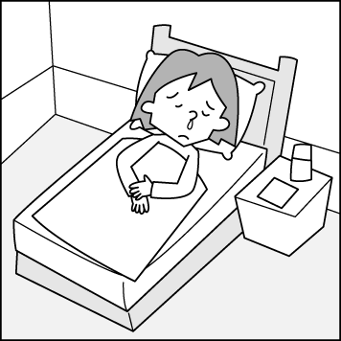
2.  (A) |  |  | (B) |  |  |  |  | (C) | 
3.
(A) | 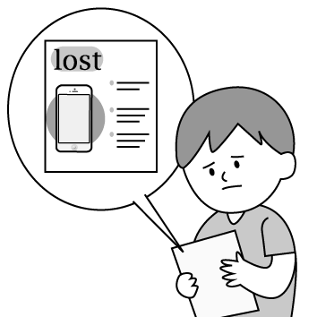 | (B ) | 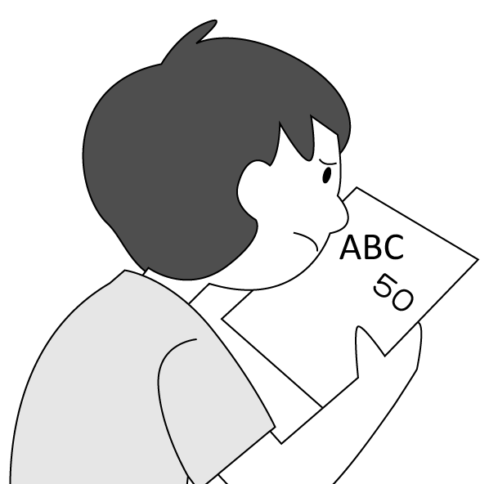 | (C) | 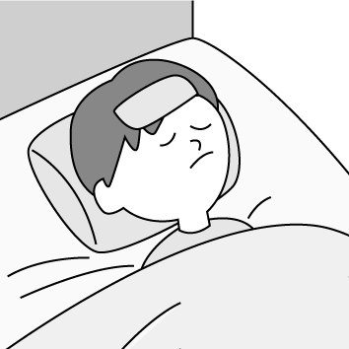
4.
(A) |  | (B) |  | (C) | 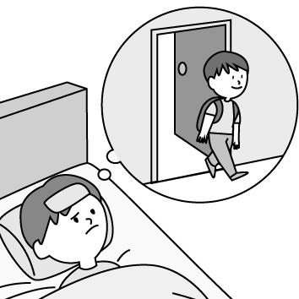

二、 基本問答：根據聽到的內容，選出一個最適合的回應或最適合的問句。每題2分
- (A) I have a sore throat. Maybe I have a cold now.
(B) It doesn’t matter if you don’t want to go with us.
(C) I was looking for a useful recipe.

- (A) Yes, they are very clean.
(B) No, one of them is clean.
(C) No, the room was very dirty.
- (A) My favorite one is Stephen Curry.
(B) Well, all of us love NBA games.
(C) The tickets to the NBA games are very expensive.
- (A) Yes, I am almost there.
(B) No, it is really not fair.
(C) Yes, count me in, please.
- (A) Yes, where do you find it? Thank you so much.
(B) Yes, the pencil looks good, too.
(C) No, I was looking for my ball.

三、言談理解：根據聽到的內容，選出一個最適合的答案。每題2分
- (A) She doesn’t like to exercise.
(B) She has a stomachache.
(C) She eats too much for breakfast.
- (A) The weather in Spain.
(B) The garlic tea and the ginger root.
(C) All kinds of yummy food around the world.
- (A) Bob will go to Tokyo with his girlfriend next week.
(B) The man doesn’t really like Disneyland.
(C) The man and the woman will go to Japan together next time.
- (A) They can get the new phone at a lower price.
(B) They want to get the latest cellphone.
(C) They can change their cellphone for free.
- (A) He helps her cook dinner every day.
(B) He helps her buy some food at the supermarket.
(C) He helps her do some housework.

四、單字、文法測驗 每題2分
15. Let’s put some ________ in the lemon juice. That’ll make it taste sweet.
(A) cheese (B) salt (C) honey (D) flour

16. The teacher is ______ the rules of the museum to the children, and they’re listening to her carefully.
(A) celebrating (B) explaining (C) exercising (D) changing

17. Sam: What’s the ________ with Peter? He looks sad.
Grace: He didn’t win the baseball game this morning.
(A) matter (B) example (C) headache (D) excuse

18. Lily didn’t go to school today because she had a high ________.
(A) stomachache (B) fever (C) runny nose (D) sore throat

19. Please take the ________ with water three times a day, and you will get well soon.
(A) garlic (B) spoon (C) throat (D) medicine

20. Ken: EggPlantEgg is my favorite singing ________. How about you?
Lian: I like BTS.
(A) group (B) grade (C) break (D) root

21. To be ________, the soup is too salty. Maybe you should add some water to it.
(A) honest (B) helpful (C) difficult (D) scary

22. The dancing contest ________ at 3:30 and ended at about 5:30.
(A) threw (B) practiced (C) began (D) won

23. We all ________ we can take a trip to Kaohsiung three months later.
(A) except (B) expect (C) pick (D) kick

24. The test was not difficult at all, so only few of the students _______ it.
(A) failed (B) passed (C) afraid (D) planned

25. My parents don’t ________ me to use the cellphone on weekdays.
(A) let (B) lead (C) count (D) allow

26. Elaine is ______ at cooking, and she often cooks yummy food for us.
(A) excellent (B) common (C) sick (D) comfortable

27. Tim had ______ of the buns this morning. Was he very hungry then?
(A) every (B) much (C) all (D) lot

28. You’ll help do the housework tonight, ________ you?
(A) will (B) won’t (C) don’t (D) are

29. Frances is never late for school, ________?
(A) is Frances (B) isn’t Frances (C) is she (D) isn’t she

30.There are five people in your family, ________?
(A) isn’t it (B) are they (C) was there (D) aren’t there

31. Richard put a flower and a card on the table before going to work, ________ he?
(A) didn’t (B) doesn’t (C) couldn’t (D) can’t

32. ________ Mary got up very early today, ________ she still missed the school bus.
(A) Because; so (B) Although; but (C) X; so (D) Although; X

33. We believe Dayou Junior High School is the best school in Taoyuan.
(A) that (B) this (C) these (D) because

34. Kyle is a hard- working student. He always spends of his time studying every day.
(A) any (B) most (C) many (D) little

35. All of the Gouda cheese very yummy.
(A) taste (B) taste like (C) tastes (D) tastes like

36. Evan went to school today although he sick.
(A) is (B) was (C) feels (D) did

37. I don’t feel like anything because I have a stomachache.
(A) eat (B) to eat (C) to eating (D) eating

38. If you study harder, you’ll enter Wulin Senior High School next year.
(A) able to (B) can (C) be able to (D) could

39. Hannah thinks ________ is fun to play basketball with friends.
(A) that (B) this (C) which (D) it

40. Angel practice playing the violin every day, doesn’t she?
(A) keeps (B) should (C)has to (D) needs

41. After running for one kilometer, ______ of Jeremy’s feet are very sore.
(A) one (B) both (C) two (D) all

42. Each of the students Mr. Kao carefully now.
(A) is listening to (B) are listening to (C) listens to (D) listened to

五、克漏字測驗 每題2分
(43.-45.)
Mark: You and Jim like baseball very much, 43. ?
Linda: Yes, we are baseball fans. We often watch baseball games together.
Mark: Here are three tickets to the baseball game.
Maybe you can go to the baseball game with me.
Linda: I’m afraid 44. I can’t go with you. I have to prepare for my test.
Mark: How about Jim?
Linda: Don’t you know he has COVID-19? He is 45. and he has to stay at home for seven days.
Mark: That’s too bad.

43. (A) don’t they (B) doesn’t he (C)don’t you (D) aren’t you
44. (A) of (B) X (C) to (D) its
45. (A) under the weather (B) taking care of (C) around the corner (D) holding back

六、閱讀測驗 每題2分
(46.-47.)
Jay Chou is one of the most popular singers in Taiwan. He was born on January 18th, 1979. At the age of three, his mother noticed his interest in music and took him to piano lessons. Because his mother always kept an eye on him, Jay practiced the piano very hard and finally developed a love for music.
Jay is famous for writing all his songs. He mixes Chinese and Western music styles to make a new kind of pop music. He talks about family values, social problems, and Chinese culture in his songs. People have used “Chou Style” to call his music and his special way of singing songs.
In 2000, Jay released his first album “Jay.” He has released an album almost every year and has sold about 30,000,000 albums around the world. Besides being a singer, Jay is also an actor and a movie director. He is truly a successful artist.
develop 發展 mix 混合 Western 西方的 style 風格 value 價值 social 社會的 release 發行 album 唱片 director 導演

46.What CAN’T we find in Jay Chou’s music?
(A) Family values. (B) Social problems. (C) Chinese culture. (D) Western famous people.

47.Which is TRUE?
(A) Jay Chou wants to be an actor in the future.
(B) Jay released his first album at the age of twenty-one.
(C) Jay can’t write any good songs.
(D) Jay’s movies are more popular than his songs.

(48.-49.)
Darcy: Hey! What are you doing?
Barnie: I’m trying to make the vegetables look green.
Darcy: You’re going to make us sick from eating too much salt!
Barnie: The cookbook says by putting some salt in the boiling water, we can keep the vegetables fresh, like they are just picked from the farm.
Darcy: I remember that salt is to fix the color, to make the water boil faster or to make the vegetables more delicious.
Barnie: So you already know that.
Darcy: But, I read a piece of news on the Net that the color of green vegetables has a lot to do with the acidity of the water.
Barnie: What do you mean?
Darcy: You can fix the color of green vegetables if you change the acidity of the water. So maybe we can try
putting something in the water.
Barnie: What if I put three spoons of salt just like what I did?
Darcy: That might only make the boiling point rise by only one-tenth of a degree. The change is very small.
Barnie: I don’t believe it!
Darcy: Then you can boil three pots of water and place different amounts of salt to find it out!
fix 固定 acidity 酸度 degree 度數 amount 量
48.What are Barnie and Darcy fighting about?
(A) How to make a delicious dish.
(B) What to put when cooking meals.
(C) Where to buy the greenest vegetables.
(D) How to fix the color of green vegetables.

49. What can something probably be?
(A) Salt. (B) Lemon juice. (C) Honey. (D) Ice.

(50.-52.)
Dear Amy,
When I first saw the photos of Zang Zang Bao on social media, my mouth began to water. Today I finally got a chance to have one after waiting in a long line. It was really delicious. After I ate it, my mouth was full of chocolate. The flavor was great. Maybe we can eat Zang Zang Bao together next time.
Grace
-----------------------------------------------------------------------------------------------------------------------------------------Dear Grace,
You finally tried Zang Zang Bao. That was great. But how does it get so popular in Taiwan? Do you know that? Well, everything began in Korea. Many actresses there ate Zang Zang Bao and didn’t wipe their mouths right away.
Then they took photos and uploaded them to social media. Because of these interesting photos, Zang Zang Bao got people’s attention. Many people in Korea stood in a line for it. Later, an actress in Taiwan did the same thing. She uploaded her photo of eating Zang Zang Bao to social media, and then many people were crazy about it, too.
By the way, I have free time this Saturday afternoon. Why don’t we meet up at Jenny’s and wait in line to enjoy some Zang Zang Bao?
Amy
Zang Zang Bao 髒髒包 social media 社群媒體
50. Zang Zang Bao also got Jack’s attention. What might he do?
(A) He might clean it. (B) He might stop eating it.
(C) He might want to know more about it. (D) He might buy it at a lower price.

51. What do we know from Grace’s letter?
(A) She can make delicious Zang Zang Bao.
(B) She had a sore throat before.
(C) It took her a lot of time to buy Zang Zang Bao.
(D) She doesn’t like Zang Zang Bao at all.

52. Which is true according to the letters?
(A) You may need chocolate when you make it.
(B) We can order Zang Zang Bao on the Net.
(C) Zang Zang Bao is yummy, but it’s dirty.
(D) You can’t wipe your mouth after eating Zang Zang Bao.

