**桃園市立大有國民中學113學年度第一學期第三次評量試卷**

|  |  |  |  |  |  |  |  |  |  |
| --- | --- | --- | --- | --- | --- | --- | --- | --- | --- |
| 年 級 | **七** | 考 試  科 目 | **英文** | | | 命 題  範 圍 | L5~Review III | 作 答  時 間 | 45分 |
| 班 級 |  | 姓 名 |  | 座 號 |  | 分 數 |  | | |

一、辨識句意：根據聽到的內容，選出符合描述的圖片或符合圖片的描述。

1. (A)　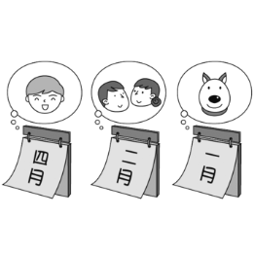  
   (B)　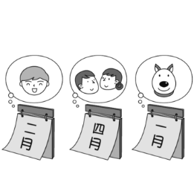  
    (C)　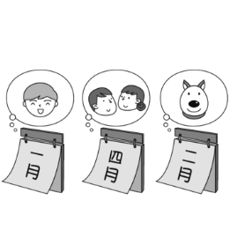
2. (A)　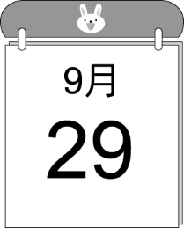  
    (B)　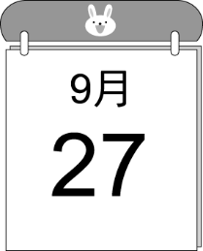  
    (C)　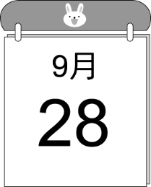
3. (A)　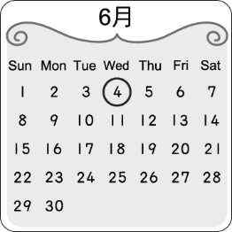  
    (B)　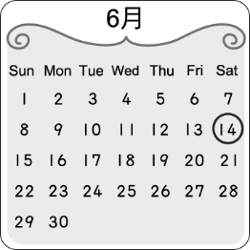  
    (C)　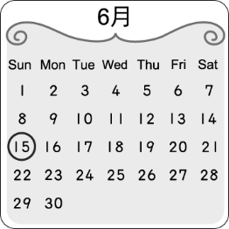
4. (A)　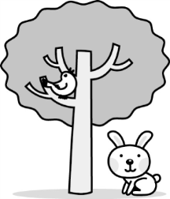  
    (B)　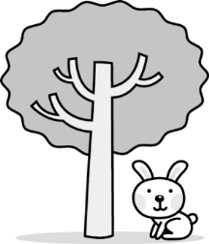  
    (C)　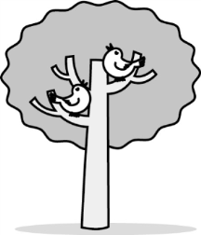
5. (A)　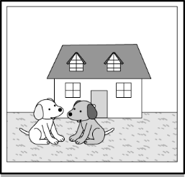  
    (B)　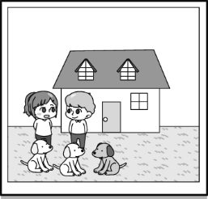  
    (C)　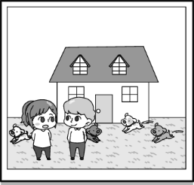

**二、基本問答：根據聽到的內容，選出一個最適合的回應或最適合的問句。**

1. (A)　My mom is busy every day.  
   (B)　Yes, I give my mom flowers.  
   (C)　No. It’s on the second Sunday of May.
2. (A)　How about you?  
   (B)　Great! I’m ready for a second one.  
   (C)　A turkey is jumping up and down on the farm.
3. (A)　They are on the desk.  
   (B)　There are some brushes and a marker.  
   (C)　Yes, the pencil case is a gift from my cousin,   
    Hulk.
4. (A)　No, there are not desks.  
   (B)　No, they are black chairs.  
   (C)　Yes, there are. Take one with you.
5. (A)　Of course! It is a gift for you.  
   (B)　No, my favorite is chocolate cake.  
   (C)　There is a glass of chocolate milk on the table.

**三、言談理解：根據聽到的內容，選出一個最適合的答案。**

1. (A)　Making a cake.  
   (B)　Writing a letter.  
   (C)　Studying and playing.
2. (A)　It is next to a school.  
   (B)　It is a house for animals.  
   (C)　It is not big enough for five people to live.
3. (A)　A sofa.  
   (B)　A desk.  
   (C)　A notebook.
4. (A)　The concert is only for students.  
   (B)　Zoe doesn’t like *Pink Zone*.  
   (C)　The concert is on September 3.
5. (A)　The boy and the girl’s good friend.  
   (B)　The boy and the girl’s new classmate.   
   (C)　The boy and the girl’s new teacher.

四、文意測驗

1. A：What is coming next week?   
   B：It’s New Year’s Eve.   
   (A) month (B) holiday (C) birthday (D) date
2. Alex is very these days. He can be happy in the morning and sad in the afternoon.  
   (A) on and off (B) before and after   
   (C) up and down (D) on and on
3. Can I be the second singer? Two is my number.  
   (A) lucky (B) important (C) great (D) only
4. Oh my dear, your bedroom is books. There are many books here and there.  
   (A) full of (B) thanks to (C) lucky with (D) healthy for
5. There are three kinds(種類) of elephants in the . One is from Asia, and two are from Africa.   
   (A) king (B) food (C) back (D) world
6. A: is Josh’s party?   
   B: It’s next weekend.   
   (A) When (B) Where   
   (C) What time (D) What date
7. The basketball game is September 15.  
   (A) in (B) on (C) at (D) of
8. A: some cookies for the party? B: Sure.   
   (A) How (B) When (C) Where (D) How about
9. A: My music concert is the third   
    January. Can you come?   
   B: Sure.  
   (A) on ﹔of (B) in ﹔of   
   (C) at ﹔and (D) on ﹔at
10. Joe and Lily’s wedding (婚禮) is week, not week.   
    (A) in next ﹔in this (B) in next ﹔this (C) next ﹔in this (D) next ﹔this
11. A: Is your birthday today, Mia? B: Yes, of October.   
    (A) the twenty (B) twenty   
    (C) twentieth (D) the twentieth
12. A: Are you free the night March 6? B: Sure.   
    (A) at ﹔in (B) at ﹔of (C) on ﹔of (D) on ﹔in
13. are some markers on the desk.   
    (A) This (B) That (C) They (D) There
14. A: there cat under the car?   
     B: Yes, there is.   
    (A) Is ﹔many (B) Are ﹔any   
    (C) Is ﹔a (D) Are ﹔a
15. On the dining table two turkey legs.   
    (A) is (B) is there (C) are (D) are there
16. A: Are there any fans near the stage? B: No, there aren’t .   
    (A) any (B) some (C) very (D) many
17. Look! There are some people over there.  
    (A) sing (B) can sing   
    (C) singing (D) are singing
18. There are horses under the tree. Aren’t they beautiful?  
    (A) some (B) no (C) any (D) a
19. A: Emily, there is a white things (東西) your   
     back.  
    B: Really? What is it?  
    (A) to (B) of (C) on (D) from
20. A: ? B: Yes, there are four rabbits over there.   
    (A) Where are the six rabbits?  
    (B) Are there three rabbits behind the box?  
    (C) What are those behind the box?  
    (D) Are there any rabbits behind the box?

五 、克漏字

|  |
| --- |
| David: What are you reading, Kelly? Kelly: A book about animals.  David: Wow, 36 two polar bears in the picture.   They are so cute. Are they a baby bear and its … dad? Kelly: No. It can 37. be the baby bear’s mom.  David: Really? Kelly: Well, for a male polar bear, 38. . David: I see. Male bears are never friends with baby bears.  Kelly: That’s 39. . David: Hey, look at the picture next to the polar bears. The   two monkeys are cute, too. 40. . Kelly: No, they’re not cleaning. There aren’t many bugs in a   monkey’s coat. The monkeys are doing this for salt.  David: That’s new 41. me.   * polar bear 北極熊 male 公的 salt 鹽巴 |

1. (A) it is (B) there is (C) they are (D) there are
2. (A) not (B) also (C) only (D) maybe
3. (A) baby bears can be his food   
   (B) baby bears are a big help to him   
   (C) baby bears are very important   
   (D) baby bears are clean and happy
4. (A) right (B) lucky (C) clean (D) full
5. (A) Are they playing with each other?  
   (B) What’s on the back of the big monkey?  
   (C) Are there any bugs on their back?  
   (D) Are they cleaning up bugs for each other?
6. (A) with (B) at (C) to (D) in

六 、閱讀測驗

|  |
| --- |
| Jim: Hello! Leo, what’s up? You look very happy.  Leo: I am very happy because this year is a “leap year.”  Jim: What is a leap year? Leo: It means there are 366 days this year.  Jim: What?! That is sad! That means we have to go to   school for one more day! Leo: Come on, Jim! Don’t be so lazy. Jim: All right. All right.  Leo: To me, it is very important because my birthday is on   February twenty-ninth. Jim: So, your family celebrate your birthday every four   year?! Leo: Yes. Now you know why a leap year is so important to   me. I am so “lucky.” Jim: My birthday is on December twenty-fourth ; we are in   the same boat. My family give me only Christmas   gifts. Why is there a leap year? Leo: People say it takes 365.25 days for the Earth to go   around the sun, to be specific. So every four year, we   have one more day. Four times 0.25 equals one.  Jim: I see.   * because 因為 mean 意指 have to 必須 more 多的 lazy懶惰的 celebrate 慶祝 know 知道 say 說 take 花費 Earth 地球 specific 準確的 equal 相等的 |

1. Why does Jim say we are in the same boat?  
   (A) His birthday is on February 29th.   
   (B) He also likes (喜歡) a leap year.   
   (C) He doesn’t want (想要) to buy any birthday gift   
    for Leo.   
   (D) His family don’t give him any birthday gift.
2. What can we know from the talk (對話)?  
   (A) Jim’s birthday is on Christmas Day.  
   (B) Leo’s birthday is on the last(最後的) day of   
    February in a leap year.  
   (C) Jim is thankful for his school life.   
   (D) Leo is sad about the coming of a leap year.
3. Which math formula (公式) can mean the coming of a “leap year”?  
   (A) 4÷1=4  
   (B) 1 × 2 = 2  
   (C) 1 – 0.5 = 0.5   
   (D) 4 × 0.25 = 1

|  |
| --- |
| Cinderella is six years old. Her father is not home, and her stepmother is bad to her. Her friends are at the park, but she can’t play with them. She is cleaning up the house. Luckily, there are some rats in the house. They are cleaning up the house with Cinderella. the rats, the house is clean. Now she can go to the park and play.  ★ stepmother 繼母 |

1. Which is the best for the blank? (空格最佳答案為何?)  
   (A) For example (B) Thanks to   
   (C) Lucky for (D) Good for
2. Which is NOT true? (何者有誤?)  
   (A) Cinderella is cleaning the house.   
   (B) Cinderella is playing with the rats.   
   (C) Cinderella’s stepmother is not nice to her.   
   (D) With the rats’ help, Cinderella can go to the park.

|  |
| --- |
| Dan: Hey, Janice. Let’s go to Ellen’s. There are not any  erasers in my pencil case, but I need one at school.  Janice: Now? It’s 9:50 p.m. The bookstore will close in   ten minutes. There is a new one on my desk. You   can use it.  Dan: Thanks, my good sister. Mom and Dad aren’t at home   now, but I am hungry.  Janice: Again?! You just ate a large pizza. I’m very full   now.  Dan: But I can’t study with an empty stomach. Let me eat a   package of instant noodles.  Janice: Give me a break. I don’t want to be fat like you.   We can only eat healthy food, and let’s not eat …. Dan: You are so right, but my stomach is saying, “I’m very,   very hungry, and give me some food, please.” Janice: I’m speechless.   * need 需要 bookstore 書店 will close in ten minutes 十分鐘後將打烊 again 再一次 just ate a large pizza 剛吃了一塊大披薩 empty stomach 空空的胃 a package of instant noodles 一包泡麵 give me a break 饒了我 like 像 speechless無言的 |

1. What is Ellen’s?  
   (A) A bookstore.   
   (B) A museum.  
   (C) A zoo.  
   (D) A park.
2. Ellen’s will close at ________________.   
   (A) 9:50 in the morning.  
   (B) 10:00 in the morning.  
   (C) 9:50 in the evening.  
   (D) 10:00 in the evening.
3. What is right about Dan?  
   (A) He can use his sister’s new eraser.  
   (B) He is tall and thin.  
   (C) He is an office worker.  
   (D) He can’t eat healthy food at home.
4. What is NOT right about Janice?  
   (A) She is nice to her brother.   
   (B) She likes to eat healthy food.   
   (C) She’s hungry, and she can’t study.   
   (D) She is right about healthy food.