**桃園市立大有國民中學113學年度第一學期第一次評量試卷**

|  |  |  |  |  |  |  |  |  |  |
| --- | --- | --- | --- | --- | --- | --- | --- | --- | --- |
| 年 級 | **七** | 考 試  科 目 | **英語科** | | | 命 題  範 圍 | Starter Unit~  Review 1 | 作 答  時 間 | 45分 |
| 班 級 |  | 姓 名 |  | 座 號 |  | 分 數 |  | | |

**聽**力測驗，每題播放兩次，請依題意選出最好的答案，共25分。

一、辨識句意：根據聽到的內容，選出符合描述的圖片或符合圖片的描述，每題1分，共5分。

1. (A)　 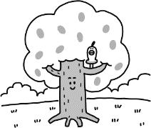 (B)　 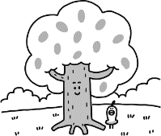 (C)　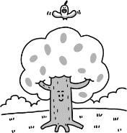

2. (A)　 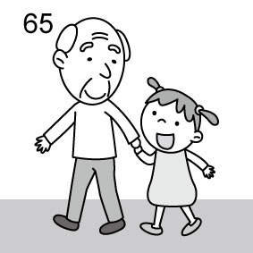 (B) 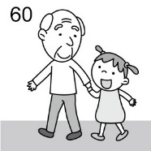 (C)　 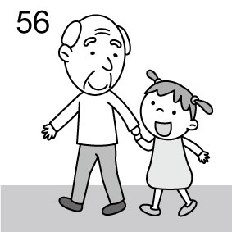

3. (A)　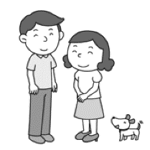 (B)　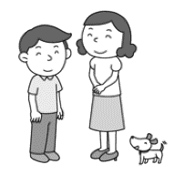 (C)　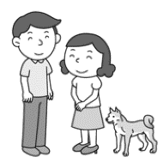

4. (A)　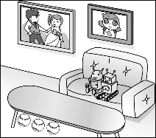 (B)　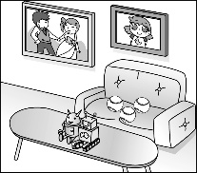 (C)　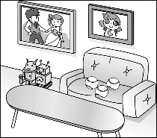

5. (A)　 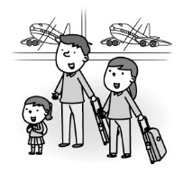 (B)　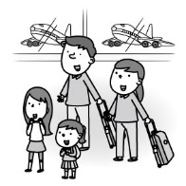 (C)　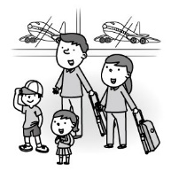

二、基本問答：根據聽到的內容，選出一個最適合的回應或最適合的問句，每題2分，共10分。

1. (A) It’s next to the kitchen.  
    (B)　It’s behind the school.  
    (C)　Mom is in the bathroom.
2. (A)　They are my brother’s books.  
    (B)　They are Kelly and Betty.  
    (C)　They are beautiful colors.
3. (A)　He is forty years old.  
    (B)　He is from Poland.  
    (C)　He is Mark’s uncle.
4. (A)　Thank you.  
    (B)　Good! Happy to meet you!  
    (C)　We are good students.
5. (A)　Yes, it’s an eraser.  
    (B)　Oh, it is on the desk.  
    (C)　No, it is Amber’s eraser.

三、言談理解：根據聽到的內容，選出一個最適合的答案，每題2分，共10分。

1. (A)　It’s on the table.  
    (B)　It’s behind the table.  
    (C)　It’s in the small box.
2. (A)　A writer. (B)　A singer. (C)　A student.
3. (A)　The man. (B)　Two doctors. (C)　The woman.
4. (A)　He is the woman’s friend.  
    (B)　He is Simon’s brother.  
    (C)　He is a nine-year-old singer.
5. (A)　In the red box.  
    (B)　In the green box.   
    (C)　In the white box.

**綜**合測驗

四、請依題意選出最好的答案，第16-30題，每題2分，共30分。

16. Look at the picture. The happy dog is _____ a small ball.

(A) on (B) between

(C)) next to (D) under

17. Mr. Wang is 75, but he looks so ______.

(A) tall (B) young

(C) small (D) long

18. The _____ of the watch is green. It’s so different.

(A) color (B) number

(C) box (D) case

19. James is my mom’s brother. His son, Pete, is my ______.

(A) uncle (B) brother

(C) aunt (D) cousin

20. It’s twelve now. The little boy is _____. He’s crying.

(A) thin (B) short

(C) hungry (D) fine

21. A: My red pens aren’t in the case. B: _____ they’re in your bag.

(A) But (B) What

(C) Right (D) Maybe

22. The brown birds _____ cute. _____ names are Bubu and Juju.

(A) is / It’s (B) are / Their

(C) are / We (D) is / Its

23. Our teacher, Miss Chen, is Jason’s sister. They’re _____.

(A) brother and sister (B) mother and son

(C) Dad and Mom (D) teacher and student

24. _____ are new. We all like them.

(A) Those cars (B) This car

(C) That car (D) Those are cars

25. A: _____ these in the bag? B: Flowers for you.

(A) How are (B) Where is

(C) What are (D) Who is

26. A: Is that tall man your brother? B: _____

(A) Yes, it is. (B) Yes, that is.

(C) No. He’s my new classmate. (D) No, it’s not.

27. A: We’re a family of five.

B: ___________________

A: They’re Grandpa, Dad, Mom, little sister and I.

(A) Who are they? (B) What are they?

(C) Where are they? (D) How are they?

28. Zac: Mom, _____, Yuki and Jamie. Mom: Hi, nice to meet you.

(A) this is my friend (B) they’re my classmates

(C) these are pens (D) they are old toys.

29. Cody: Dad, __________________ Dad: Come on, Cody. It’s on your hand.

(A) is this your pen? (B) where is the dog from?

(C) are they sixteen? (D) where is my watch?

30. A: I love this singer, Bruno Mars.

B: ________________________

A: He’s 38 now.

(A) Where is he? (B) How tall is he?

(C) Who is he? (D) How old is he?

五、克漏字及閱讀測驗，第31-40題，每題2分，共20分。

A.

|  |
| --- |
| (Ken and his mom are in Ken’s classroom)  Ken: Welcome to our class.  angry mom clipart - Clip Art Library Mom: Your classroom is big and clean. 31.  Ken: Oh, here. This is my desk.  Mom: It’s so dirty. Are those your 32. on your desk?  Ken: Yes, they are. And the new comic books from the bookstore 33. .  Mom: Too many things! How about this card?  Ken: 34. 35. my English test paper.  Mom: Not again, Ken! |

|  |  |
| --- | --- |
| 31. (A) What’s this? | (B) Where’s your desk? |
| (C) Is it your desk? | (D) How’s your classroom? |
| 32. (A) a lunch box | (B) lunch box |
| (C) lunch boxes | (D) the lunch boxes |
| 33. (A) is in front of the door | (B) are under my chair |
| (C) is next to my school bag | (D) are right in the park |
| 34. (A) That’s not a card. | (B) The card is for you. |
| (C) It isn’t his card. | (D) That is your birthday card. |
| 35. (A) Its | (B) It’s |
| (C) His | (D) We’re |

B.

|  |
| --- |
| Hi, my name is Amy. The people in the picture are my three good friends. They are Ted, Peter, and Patty. The short girl between the two boys is my classmate, Patty. She’s nice and happy to help everyone. The boy, Peter, is not my classmate. He’s my cousin. We’re in the same school. He’s very tall, and he is a basketball player, too. Ted is not so tall, but he’s a basketball player, too. His mom is a teacher. **She**’s nice to us. |

|  |  |
| --- | --- |
| 36. What is the reading about? | |
| (A) Family. | (B) Cousins |
| (C) Schools. | (D) Friends. |
| 37. Who’s **She**? | |
| (A) She is Amy. | (B) She is Patty |
| (C) She’s Ted’s mom. | (D) She’s a baketball player. |
| 38. Amy is talking about picture _____. | |
| (A) 一張含有 足部穿著, 男孩, 卡通, 球 的圖片  自動產生的描述  Ted Patty Peter | (B) 一張含有 足部穿著, 男孩, 卡通, 球 的圖片  自動產生的描述  Peter Amy Ted |
| (C) 一張含有 足部穿著, 男孩, 卡通, 球 的圖片  自動產生的描述  Ted Amy Peter | (D) 一張含有 足部穿著, 男孩, 卡通, 球 的圖片  自動產生的描述  Peter Patty Ted |

C.

The Cube Houses are in the Netherlands. Each Cube House looks like a box. The houses are small on the outside, but they’re big inside. The door is on the first floor. People can cook and watch TV on the second floor. On the third floor, people can sleep there. They have big windows in the cubes. The houses are bright. And they’re close to each other, it’s easy for people to meet and make friends!

✐ Netherlands荷蘭 look like看起來像 first第一 second第二 third第三

Floor樓層bright明亮的 close 接近的make friends交朋友

|  |  |
| --- | --- |
| 39. These Cube Houses aren’t ______. | |
| (A) in the Netherlands | (B) bright inside |
| (C) easy to make friends | (D) small inside |
| 40. Amy’s dad is watching TV now. Where is he? | |
| (A) He’s in a box. | (B) He’s on the first floor. |
| (C) He’s on the second floor. | (D) He’s outside the house. |

<<**尚有試題，請仔細作答**>>