桃園市立大有國民中學110學年度第二學期第二次評量試卷
年 級 | 七 | 考 試  科 目 | English |  |  | 命 題  範 圍 | Book2 U3-4  Review2 | 作 答  時 間 | 45分
班 級 |  | 姓 名 |  | 座 號 |  | 分 數
第一部分：聽力測驗 (1-14題)
- 辨識句意：根據聽到的內容，選出符合描述的圖片或符合圖片的描述。(每題1分)
1. | (A)  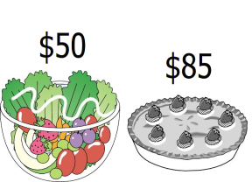 | 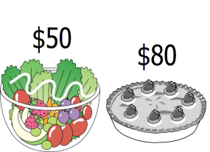  (B) | 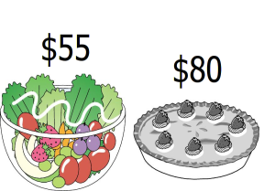  (C)
2. | 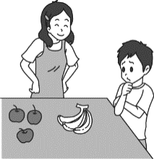  (A) | 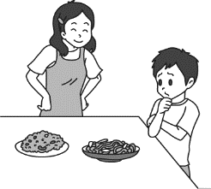  (B) | 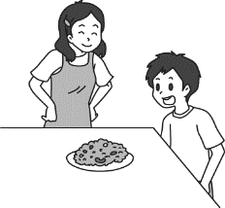  (C)
3. | 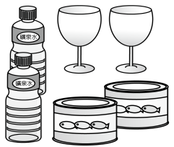  (A) | 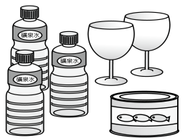  (B) | 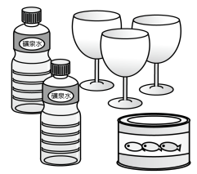  (C)
4. | 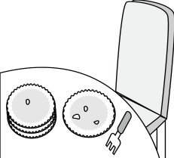  (A) | 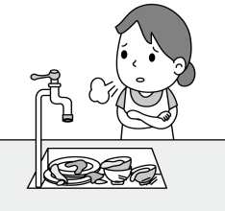  (B) | 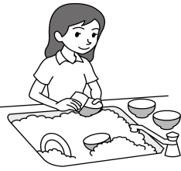  (C)

- 基本問答：根據聽到的內容，選出一個最適合的回應或最適合的問句。(每題2分)
5. | (A) I don’t like my breakfast. | (B) The food there is expensive. | (C) I need a bag of sugar and ten eggs.
6. | (A) There are two bags of sugar. | (B) There are two boxes in it. | (C) There is a bottle of chocolate milk.
7. | (A)No, thanks. I don’t drink coffee. | (B) Yes, that’s a new blender. | (C) Sure! Oh, it’s really yummy.
8. | (A) I eat one pie every day. | (B) Thank you very much. | (C) You’re bad to me.
9. | (A) Great! It’s very yummy. | (B)It’s three hundred and fifty dollars. | (C) I don’t like the music there.

- 言談理解：根據聽到的內容，選出一個最適合的答案。(每題2分)
10. | (A) The man is full.  (B) The woman can eat a lot of food.  (C) The woman doesn’t want anything for dinner.
11. | (A)The man wants a glass of cola.  (B) The woman has milk tea.  (C) The man needs a glass of water.
12. | (A) Sarah is a baby.  (B) John is making baby food.  (C) John and Sarah are going to a food shop.
13. | (A) They are talking about good concerts.  (B) They are talking about people’s names.  (C) They are talking about their favorite singer.
14. | (A) They may be at a cake shop.  (B) They may be making a cake at home.  (C) They may be selling cakes at the park.

第二部分：選擇題 (15-44題)
一、綜合測驗：每題2分
15. My grandmother is a great cook. Everyone in my family her food very much.
 | (A) places | (B) shops | (C) treats | (D) enjoys
16. Harry Potter is a famous novel J. K. Rowling.
 | (A) with | (B) by | (C) in | (D) of
17. My sister has a little baby, and her name is Jess, short Jessica.
 | (A) as | (B) with | (C) of | (D) for
18. A: May I your guitar? B: Sure. Be careful with it.
 | (A) lend | (B) borrow | (C) give | (D) buy
19. A: I am so thirsty. B: Let’s go to the coffee shop. A: Oh, that’s so sweet of you. Thank you.
 | (A) Good for you. | (B) Take it easy. | (C) It’s my treat. | (D) For here or to go?
20. We need to buy to make a pumpkin pie for Mother’s Day.
 | (A) a bag of flours | (B) a box of eggs | (C) a milk | (D) some sugars
21. My little boy, Johnny, likes .
 | (A) apple and orange | (B) chicken rice | (C) popcorns | (D) fried noodle
22. A: Do you want some candy? B: Yes! But not too much, just , please.
 | (A) a little | (B) a lot of | (C) a lot | (D) any
23. Mimi has many dolls, but that with big blue eyes is her favorite.
 | (A) one | (B) the one | (C) it | (D) them
24. How much is that chocolate cake?
 | (A) It’s five hundred eighty dollars. | (B) There are two chocolate cakes in the kitchen.
 | (C) That’s too much. | (D) They’re seven hundred twenty dollars.
25. I don’t have free time after school. I need to go to cram school. I always feel tired.
 | (A) a lot | (B) some | (C) much | (D) a little
26. A: salt do you need for the fish soup? B: I don’t need it. Thanks.
 | (A) What | (B) Which | (C) How many | (D) How much
27. A: Do you know the girls sitting on the bench?
B: Sure. The tall is my cousin, and the short are my friends.
 | (A) one ; ones | (B) ones ; ones | (C) ones ; one | (D) one ; one
28. there two plates of fried rice on the table?
 | (A) Is | (B) Are | (C) Has | (D) Does
29. I don’t like this phone. Can you show me one?
 | (A) the other | (B) other | (C) another | (D) the
30. A: do you want, hot tea or iced coffee?
B: May I have some hot water? I never drink tea or coffee at night.
 | (A) How | (B) How much | (C) What | (D) Which
31. A: B: Three.
 | (A) How much sugar is there? | (B) How much sugar does he want?
 | (C) How many sugar do you have? | (D) How many bags of sugar are there?

二、閱讀測驗：每題2分
(一)
One day, John got a letter from Mary.  Dear John,  I’m sorry, but it’s time to say goodbye. I have a new boyfriend. Would you please send my pictures back? I want to give them to my new boyfriend.  Mary | A few days later, Mary got a box. And there are many pictures and a letter in the box.  Dear Mary,  Sorry, I have too many girlfriends. Please find your pictures by yourself.  John
32. How did John feel after he got (收到) the letter from Mary?
 | (A) Nervous. | (B) Thankful. | (C) Unhappy. | (D) Worried.
33. What is the relationship (關係) between Mary and John?
 | (A) Sister and brother. | (B) Wife and husband.
 | (C) Girlfriend and boyfriend. | (D) Mother and son.

(二)
Turtles  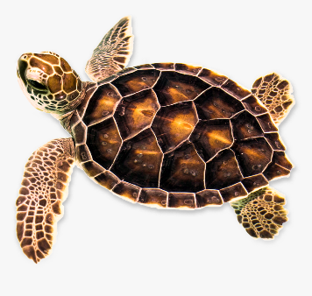  Most turtles eat fish, sea grass, and small sea animals. They spend a lot of time in the water. When mother turtles must lay their eggs, they leave the sea and go to the beach. Turtles swim, but they also climb on a rock and get warm in the sun. They can live for at least 20 years.  spend花時間；leave離開 | Tortoises  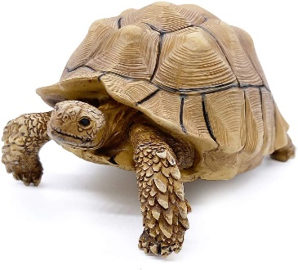  Most tortoises are herbivores. In other words, they don’t eat meat. They live on land, and most tortoises don’t swim. When they need to lay eggs, they use their strong legs to dig holes. When it is too hot, they like to stay underground. They can live for over 80 years.  land陸地；hole洞；underground地底下
34. What may a turtle do on a sunny day?
 | (A) Swim in the sea. | (B) Stay on a rock. | (C) Stay in a hole. | (D) Go to the beach.
35. What does a herbivore eat?
 | (A) Vegetables and fruit. | (B) Meat. | (C) Small sea animals. | (D) Everything.
36. On which website may you find this reading?
(A)About turtles and tortoises │ Animal World
www.animalworld.com/facts/turtlesandtortoises
What is it? Turtle or tortoise? Check out….
(B) Turtles and Tortoises │ Movie
www.movienetwork.com/ turtlesandtortoises
The movie, Turtles and Tortoises, will be on the big screen next week.
(C) Tommy and Gina are good friends │ Story Online
www.thebestfriends.com/story
Tommy the turtle, and Gina the tortoise, are best friends. They like to share everything…
(D) Print(列印) a turtle and a tortoise key chain │ 3D Printer
www.keychain.com/doityourself/turtlesandtortoises
Check out our cute turtle and tortoise key chains….

(三)
People often lie. Studies show that people lie once every ten minutes when they talk. But how do we know when someone is telling a lie to us?
First, their eyes say a lot. When people are telling lies, their eyes change their focus very quickly. They look at us this moment, and the next moment they look somewhere else. They close and open their eyes often, too. They blink their eyes many times in a short time. They may also move their head, touch their face, or bite their lips. Besides, they may sound different. For example, they may suddenly talk louder or repeat words.
In fact, people aren’t very good at spotting lies. At best, we can only tell half of the lies. So, learn the signs and try to use them to spot any lies. By this, we can not be fooled.
lie謊言、說謊；when 當；focus焦點；spot看出；at best最多；tell 分辨；sign跡象；fool愚弄

37. What is the reading about?
 | (A) How often people tell a lie. | (B) How to tell(分辨) if (是否)people are telling lies.
 | (C) People always tell lies. | (D) Our eyes can fool others.
38. What do people do when they blink their eyes?
 | (A) They close and open their eyes. | (B) They spot someone’s telling a lie.
 | (C) They look at someone straightly(直直地). | (D) They bite their lips.
39. According to the reading, what isn’t true about telling a lie?
(A) When people lie, they may talk louder.
(B) People may touch their face when telling a lie.
(C) We can easily tell(分辨) if someone is telling a lie.
(D) When people are telling lies, they change what they are looking at.

三、克漏字測驗：每題2分
Sometimes you go __40.__ and buy many things, but you don’t really need them. What can you do? Maybe these tips can help you. First, __41.__. Before you buy anything, stop for a second and ask yourself, “Do I need it, or do I want it?” Don’t buy things just because you want them . Only spend money on necessary things. Second, make a shopping list. Shopping with a list stop you from walking around the store and buying the things __42.__. Can’t these two tips help you? __43.__ to use the 30-day-rule. When you see something you like and you really want, __44.__. Maybe after some time, you don’t want it. Follow the tips and save money.
tip訣竅；necessary必要的；list清單；stop … from…阻止…免於…
40. | (A) fishing | (B) surfing | (C) walking | (D) shopping
41. | (A) remember to check the price |  | (B) never buy the things on the Net
 | (C) only buy the things on sale |  | (D) think twice before you buy
42. | (A) you don’t need |  | (B) you really want
 | (C) you like |  | (D) you can’t use
43. | (A) Try | (B) Do | (C) Be | (D) Hope
44. | (A) save the money |  | (B) take it home
 | (C) wait for a month |  | (D) tell your friends

